6 在VScode裡面來寫typeScript

但首先要安裝npm而node.js裡面就有附含npm，所以我們來依照底下這個來進行安裝

<https://github.com/darbyluv2code/fullstack-angular-and-springboot/blob/master/install-angular-tools/ms-windows/install-ms-windows.md#permissions-issue-with-tsc>

遇到tsc.ps1 未經數位簽署。您無法在目前的系統上執行此指 令碼。如需關於執行指令碼及設定執行原則的詳細資訊 typescript

目前解決方案

<https://officeguide.cc/powershell-set-execution-policy-remote-signed/>

7

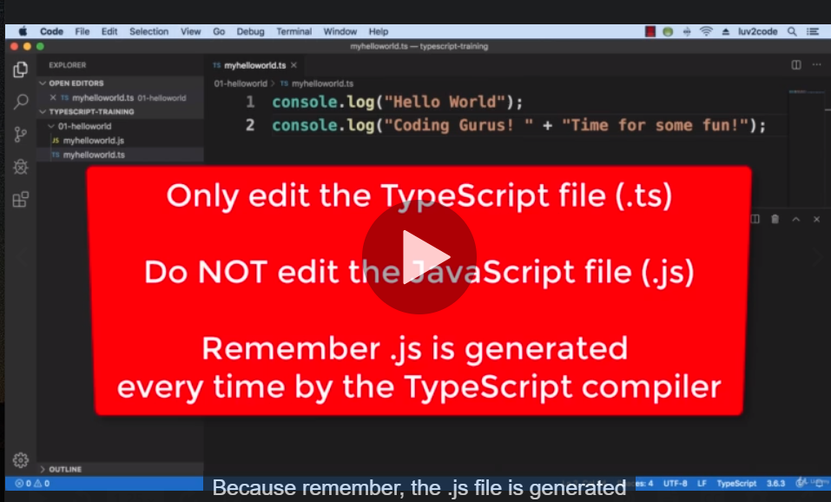

10 typescript loop array

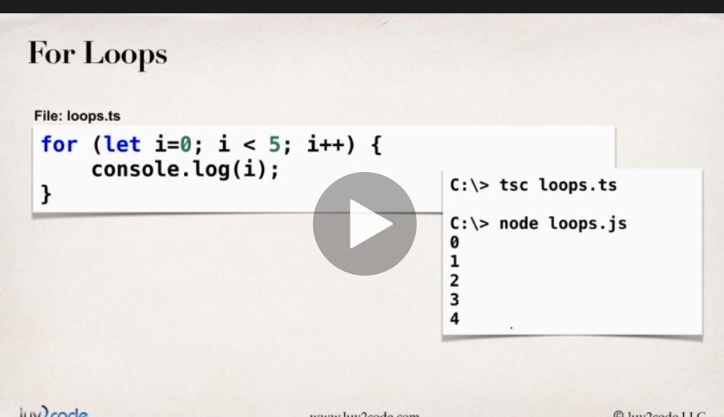

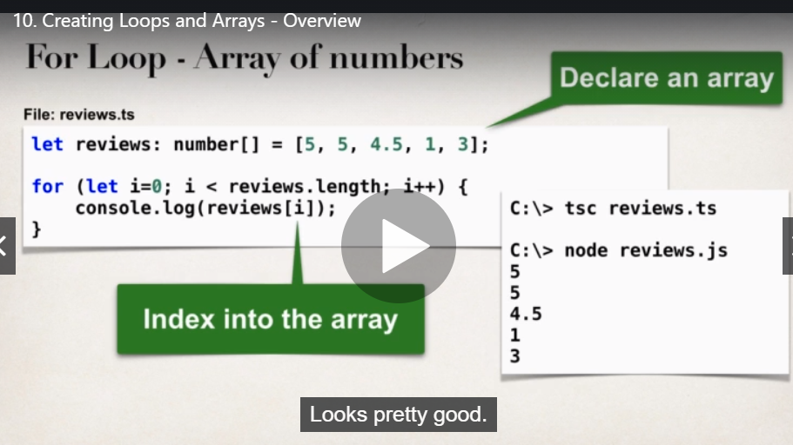

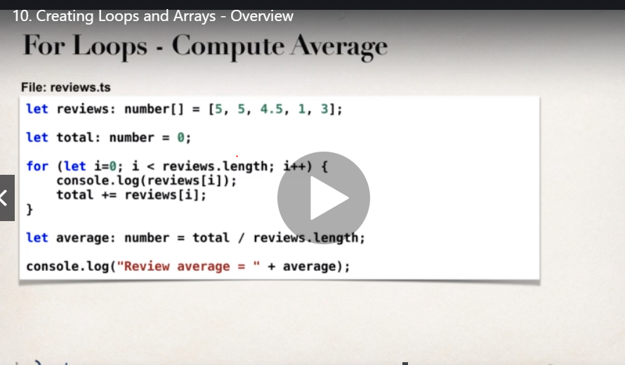

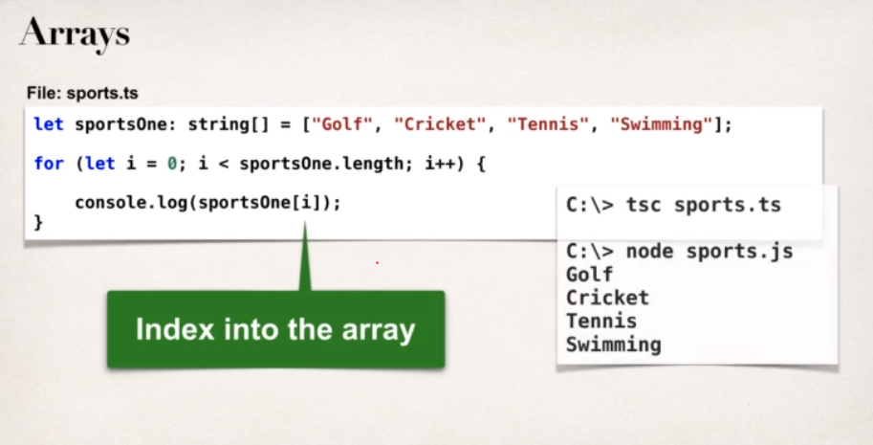

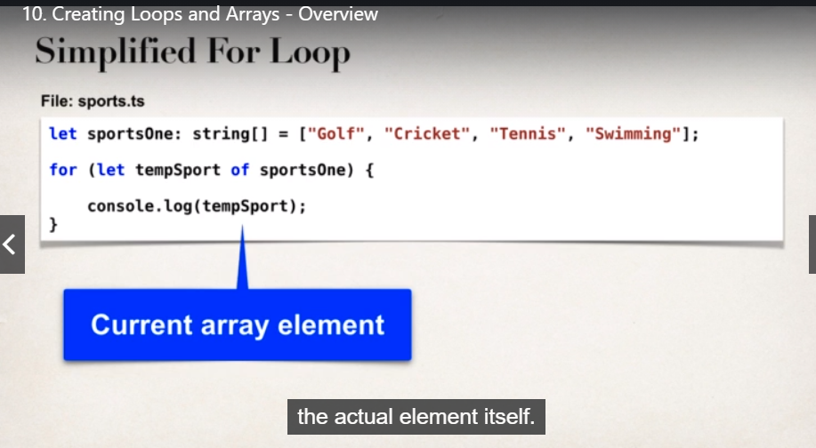

Conditionals

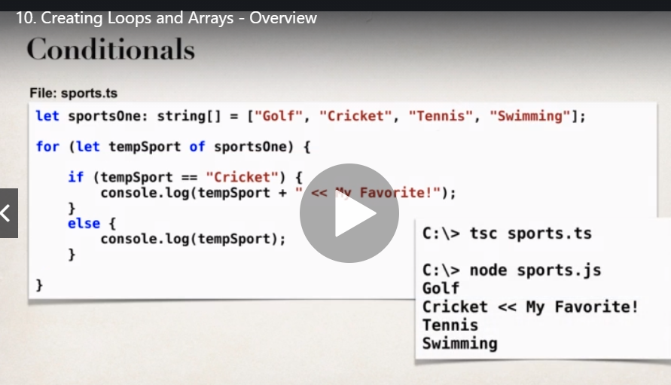

Growable arrays

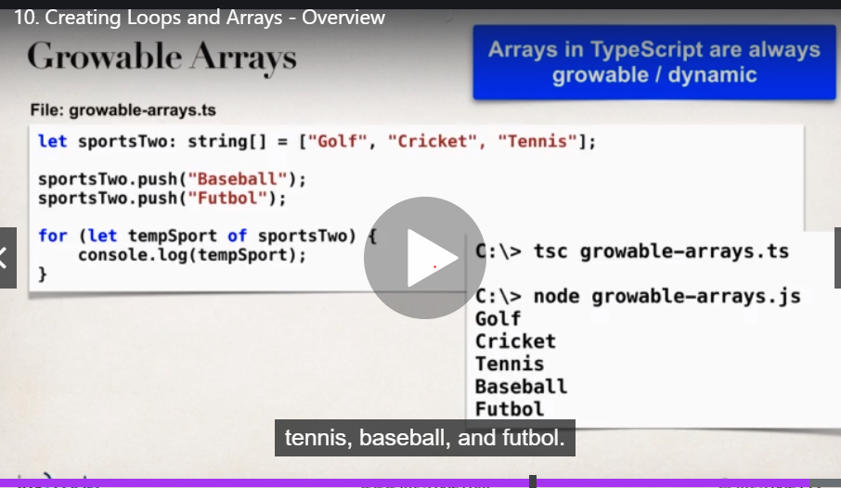

13 在ts裡面創建class 以及constructor

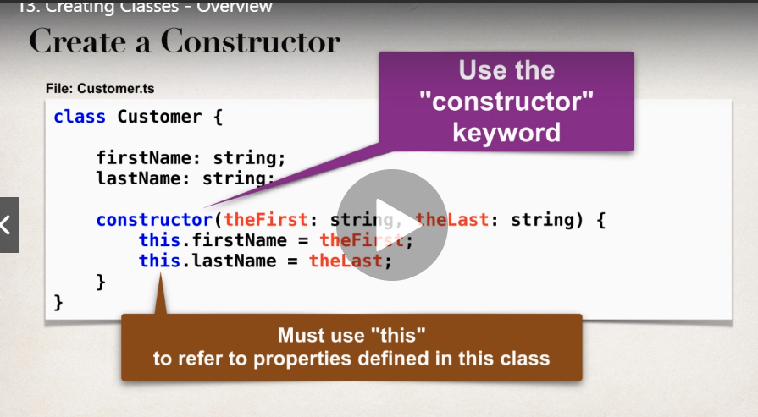

如果ts有錯 仍然會compile it 所以加上如下這段就可以讓有錯時不是繼續compile

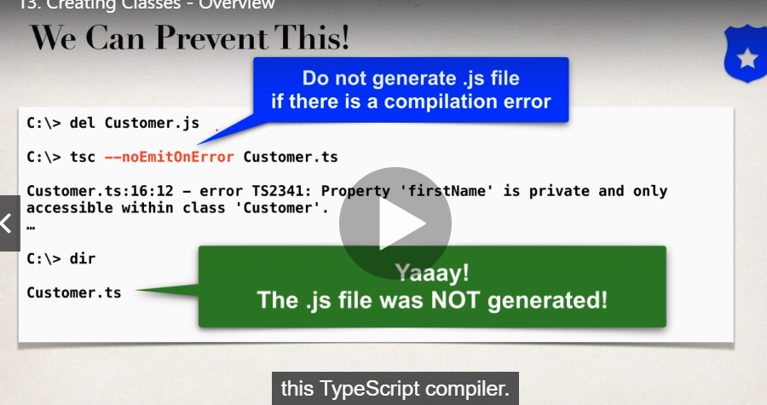

15 getter and setter(也稱為accessors

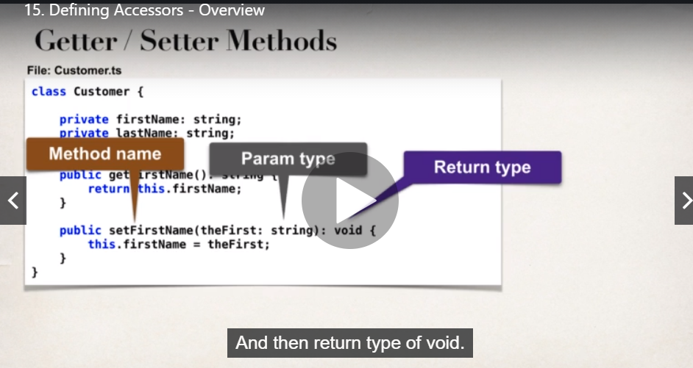

預設是public

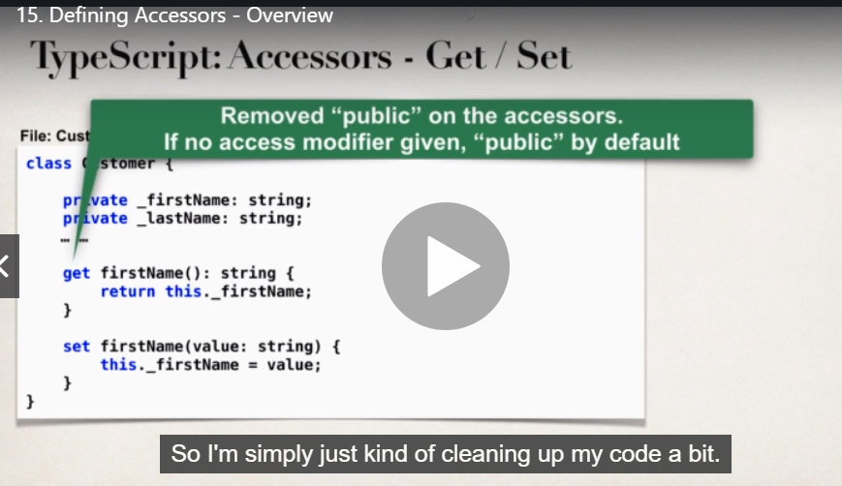

要加上compiler flag target ES才能跑

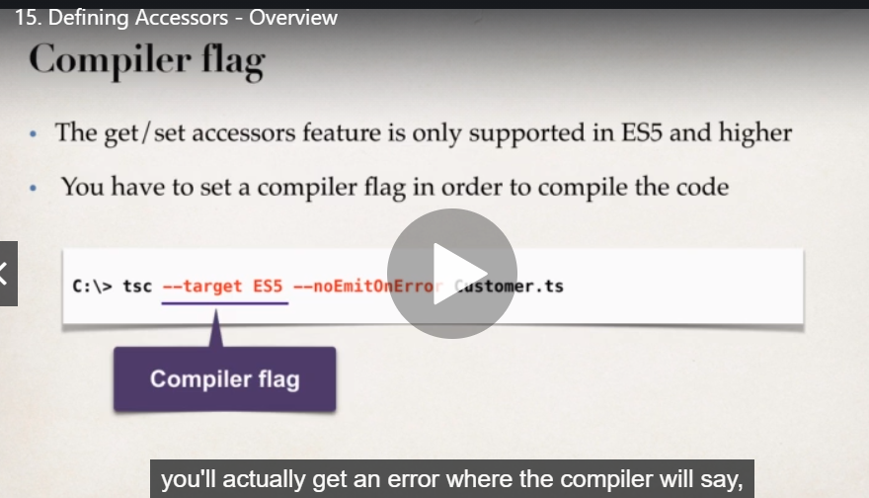

怕麻煩或忘記 所以我們另外開一個json檔案當作設定檔

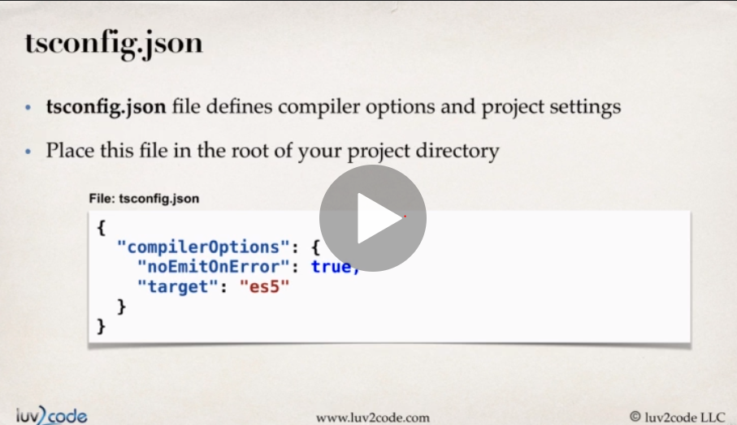

16 產生getter setter 可以用typescript tool box 安裝以後 按ctrl+shift+p打generate就會看到產生getter跟setter的選項了

Compile產生Customer.ts:14:13 - error TS1056: Accessors are only available when targeting ECMAScript 5 and higher.錯誤 因為沒有寫compiler flag

Compiler flag要寫上—target ES5

17

Tsconfig

在終端機打tsc –init就會自動產生 ，編輯好這個Tsconfig後，我們只要打tsc就可以編譯好，不用打整個tsc加檔名

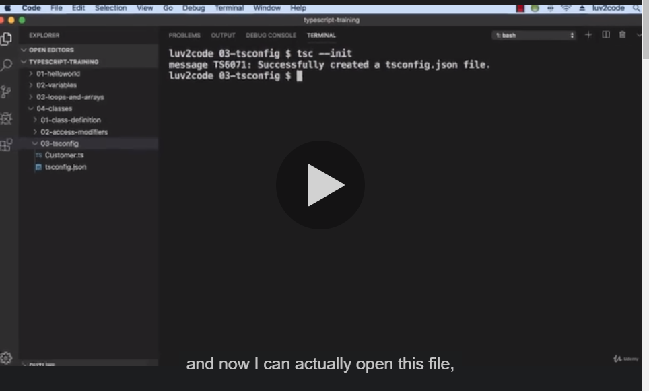

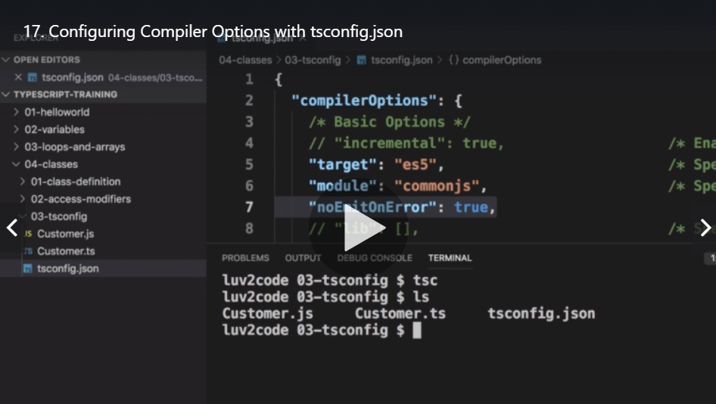

18 傳統與簡潔版的paramerer properties

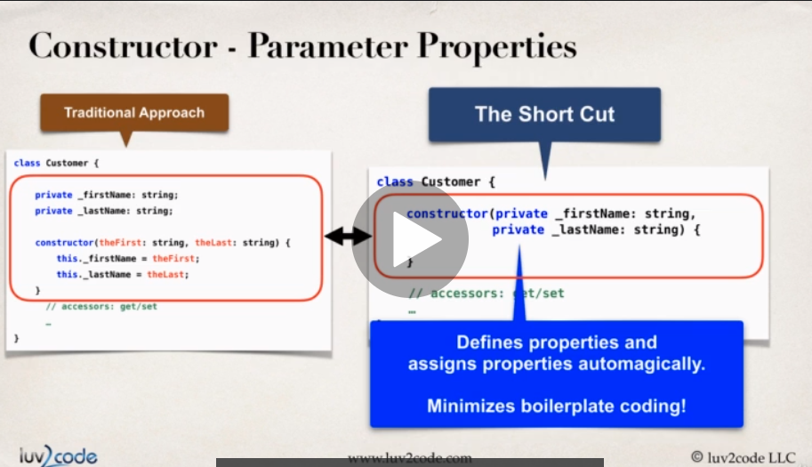

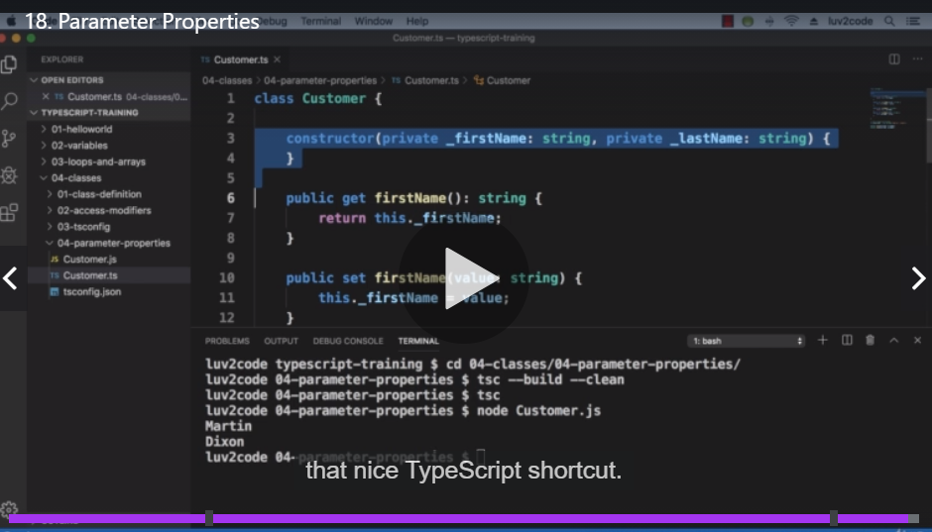

29 angular CLI start

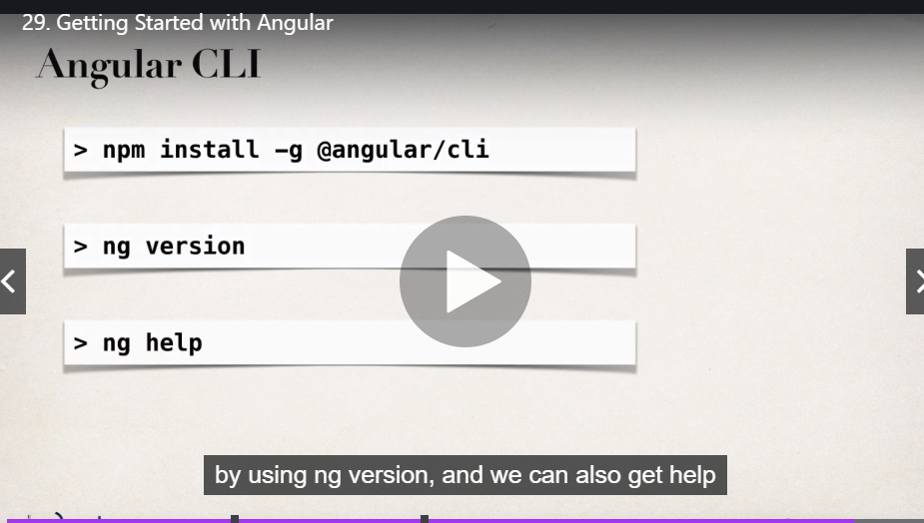

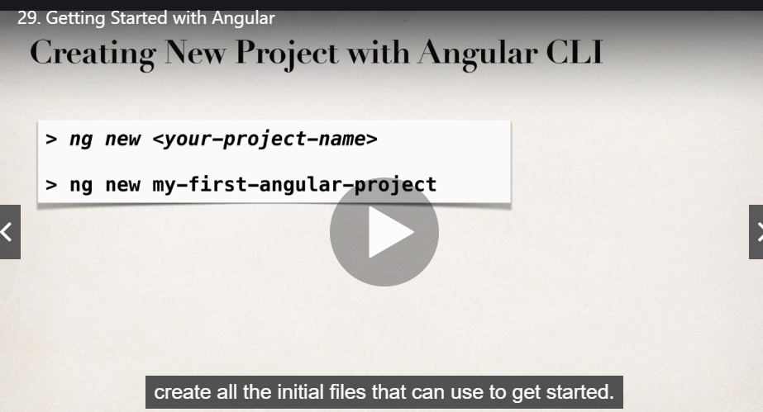

30 running the angular app

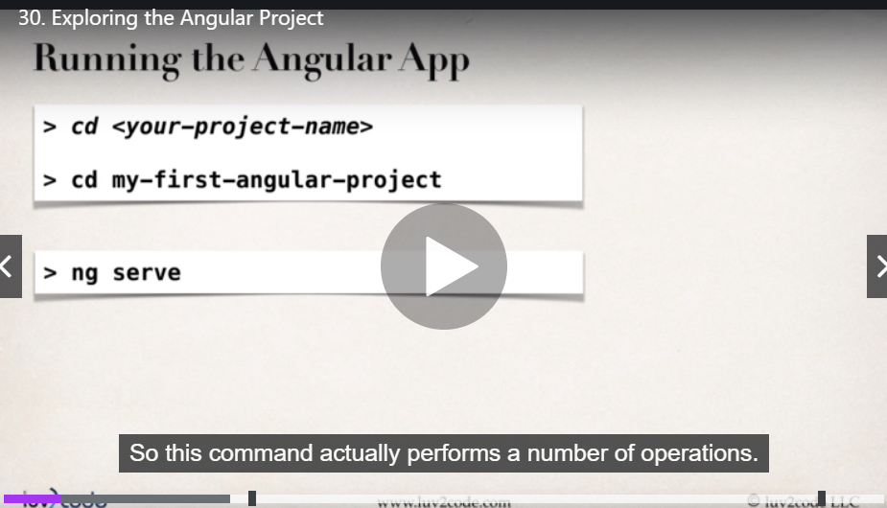

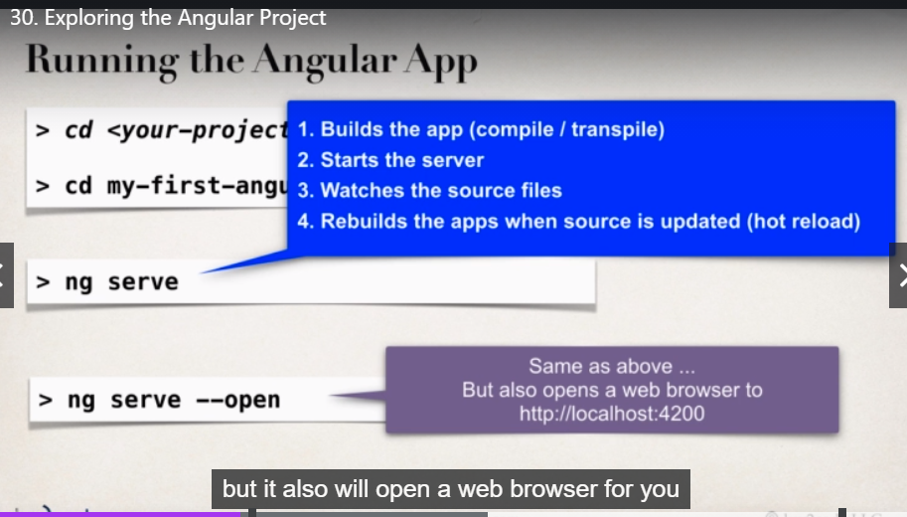

Change the server port

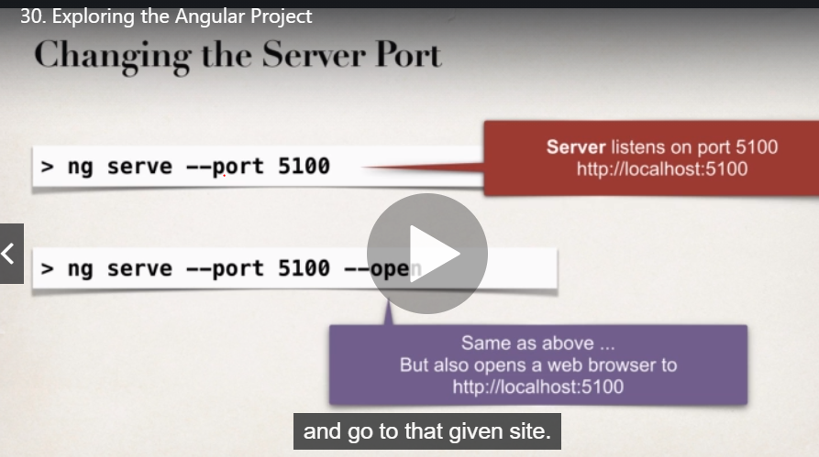

這篇裡面還有 angular的檔案夾資料架構介紹

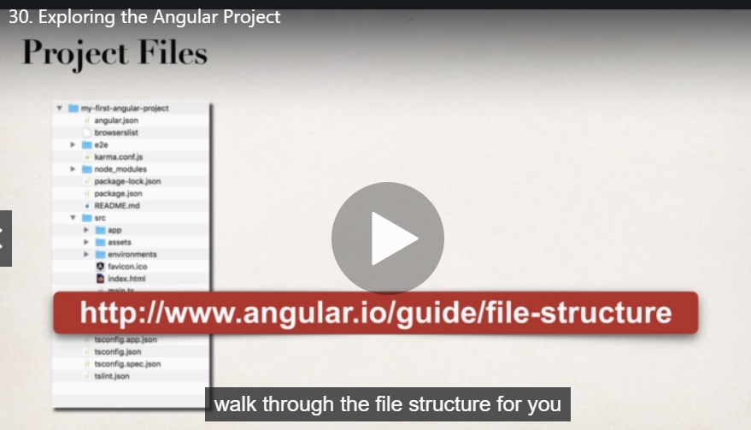

31 安裝angular

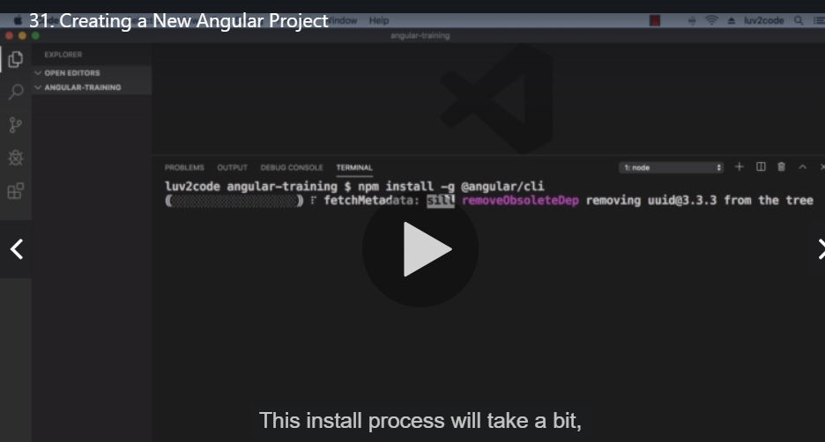

利用 ng version測試是否有安裝成功

建立第一個angular project

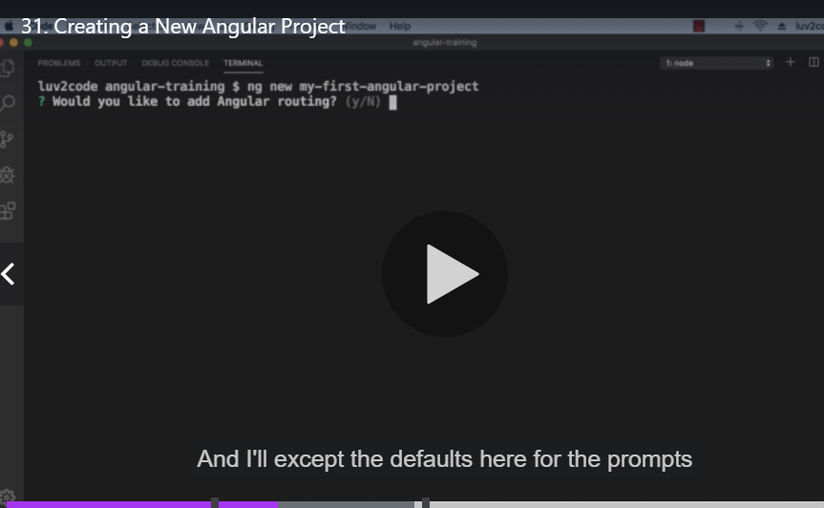

啟動angular project

ng serve

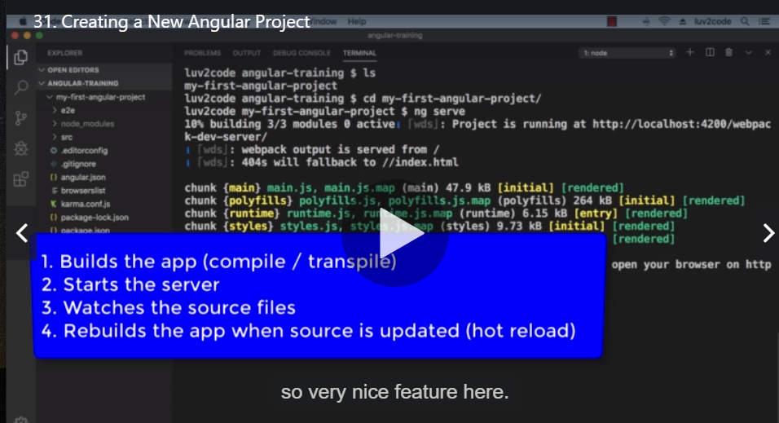

36 run the angular project and open

ng serve –open

建立 component 稱做 sales-person-list

Ng gemerate component sales-person-list

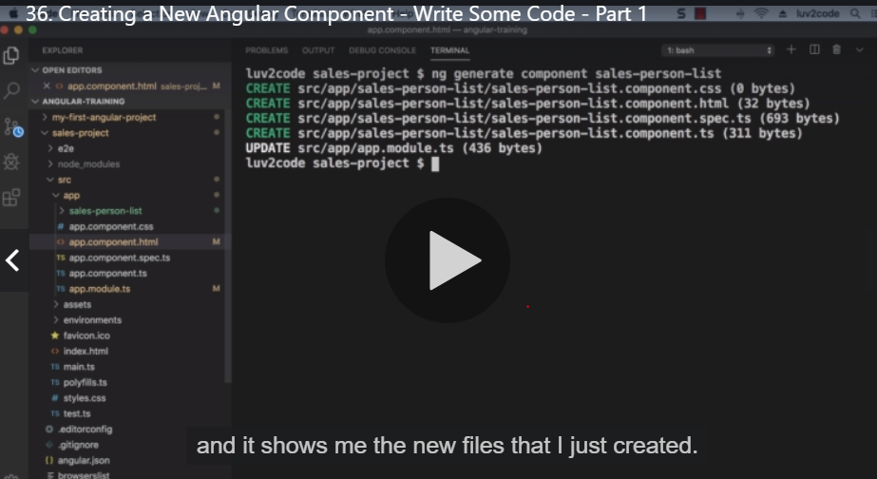

產生 SalesPerson class的ts檔

ng generate class sales-person-list/SalesPerson

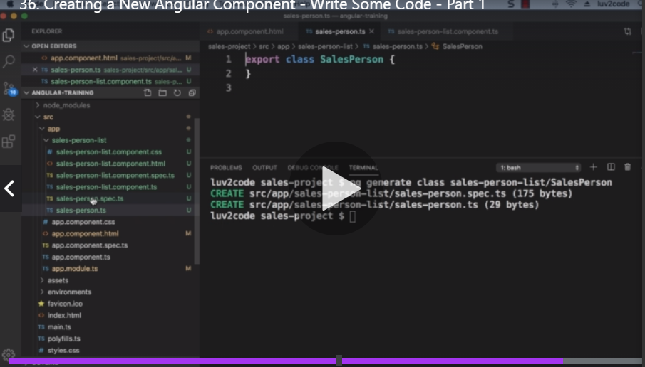

45 spring boot project set up

Lombok annotation可以自動生成setter跟getter 不用再寫出來

安裝

https://matthung0807.blogspot.com/2019/09/eclipse-lombok-installation.html

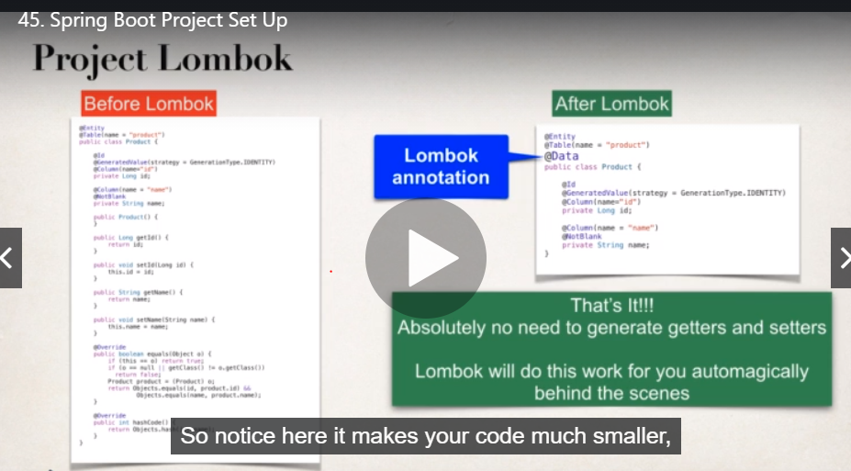

48 start the spring boot

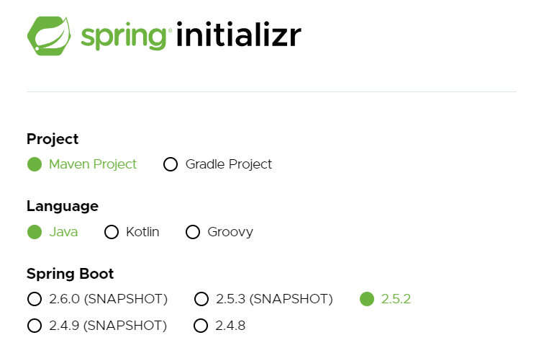

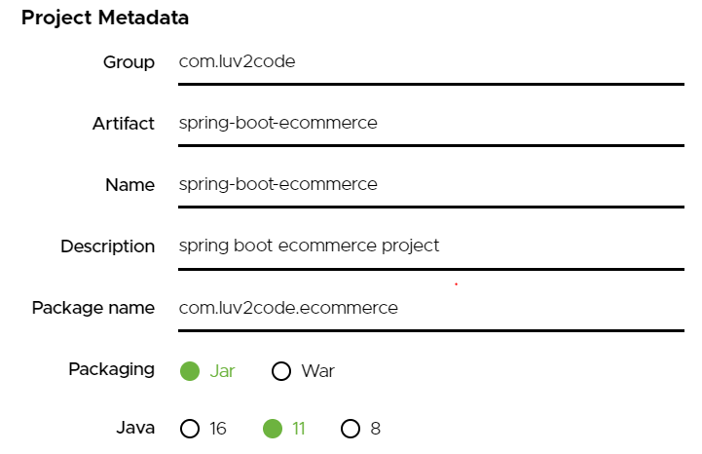

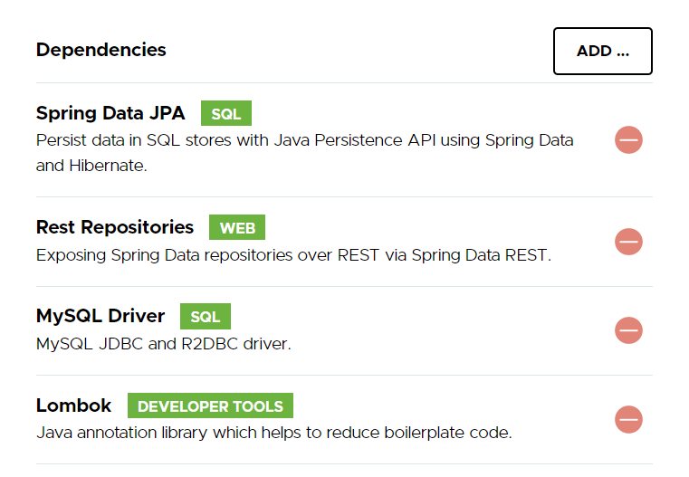

**49 entity lombok annotation 自動產生getter setter behind the scenes**

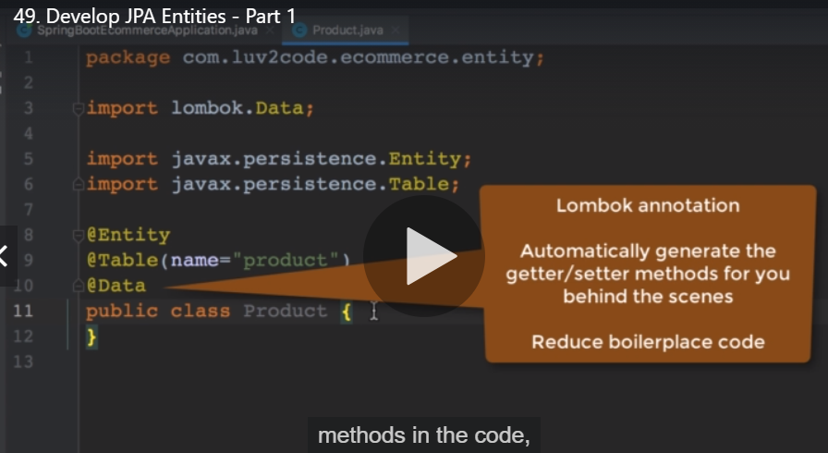

**@creationTimestamp**

**@updateTimestamp**

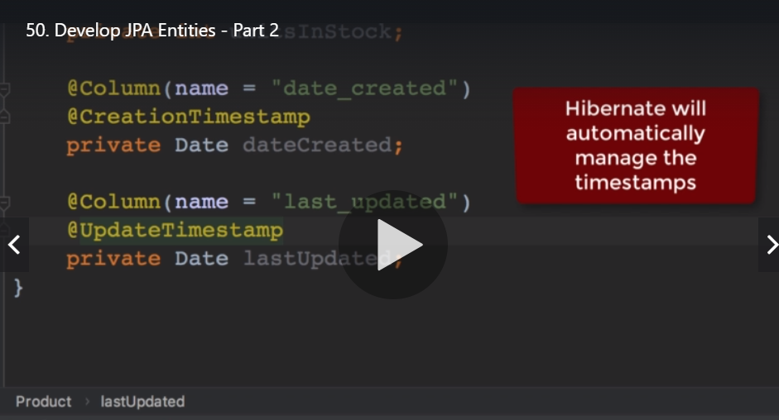

**52 rest api**

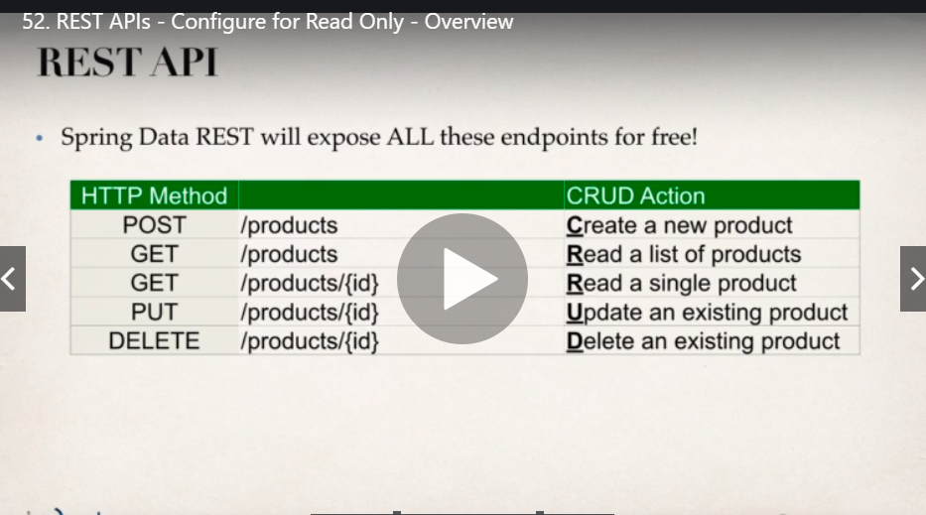

**57 創建購物車的angular 宣告class中的變數出現錯誤**

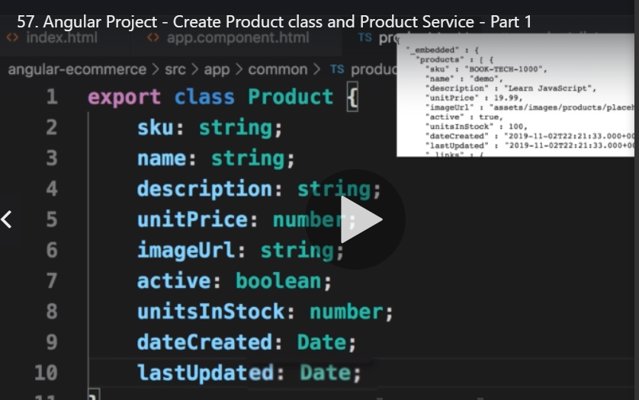

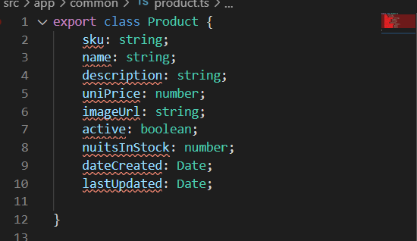

**解決方案**

1. (updating tsconfig.json with "strictPropertyInitialization": false,  now fixes my compilation error)
2. 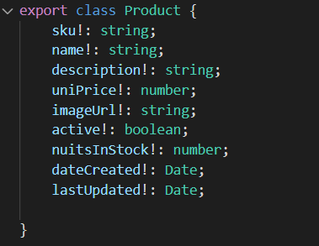

**62 assets資料夾可以拿來放圖片 js css pdf等等**

**66 安裝bootstrap**

**Npm install bootstrap**

**如果遇到問題就 npm audit fix**

**npm install @fortawesome/fontawesome-free**

**67 angular.json中的”style[“src/style.css”]是對整個app的**

**我們再加上”node_modules/bootstrap/dist/css/bootstrap.min.css”跟[node_modules/@fortawesome/fontawesome-free/css/all.min.css](mailto:node_modules/@fortawesome/fontawesome-free/css/all.min.css)**

**71不懂為何改了這邊 這葉載入的就會變多**

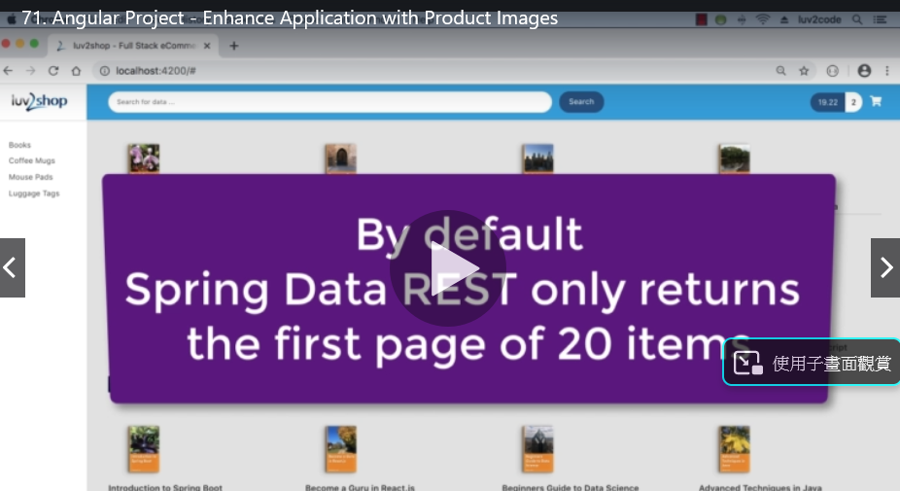

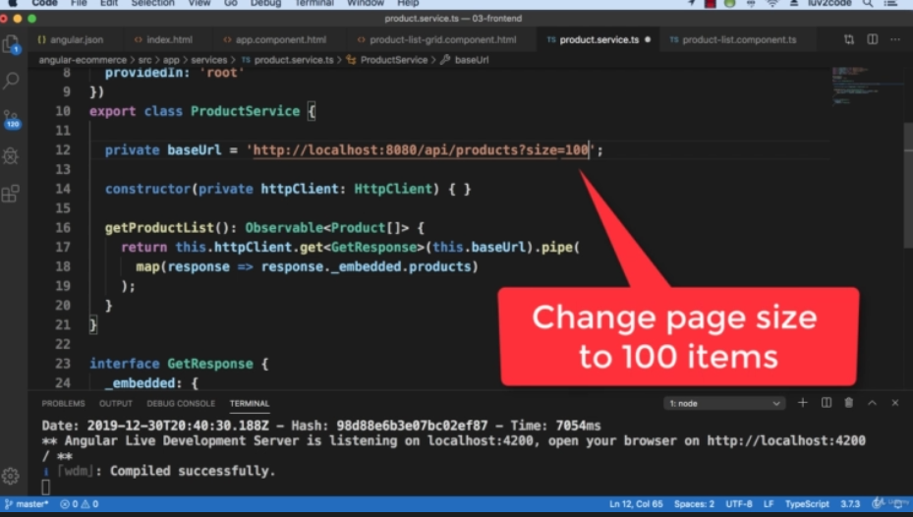

However, if you need to display BLOB images in an Angular app, here is a tutorial that shows you how:

<https://grokonez.com/frontend/angular/angular-4-uploadget-images-tofrom-spring-boot-server>

And if you’d like a comparison of the storage methods (BLOB vs file), see the links below. They cover the pros/cons of each approach

<https://teamtreehouse.com/community/storing-image-in-database-compare-with-storing-at-the-folder-server>

<https://habiletechnologies.com/blog/better-saving-files-database-file-system/>

<http://www.webdevdesigns.com/newsroom/blob-vs-file-system/>

Finally, here's a good discussion on this topic on stackoverflow. You can see different viewpoints from other developers

Storing Images in DB - Yea or Nay?

<https://stackoverflow.com/questions/3748/storing-images-in-db-yea-or-nay>

**73 \*\***

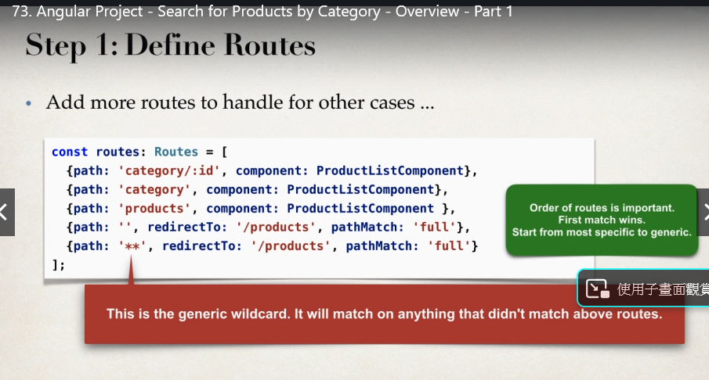

**74**

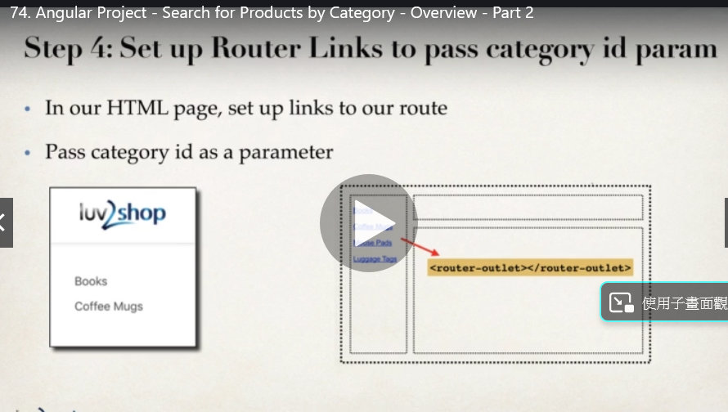

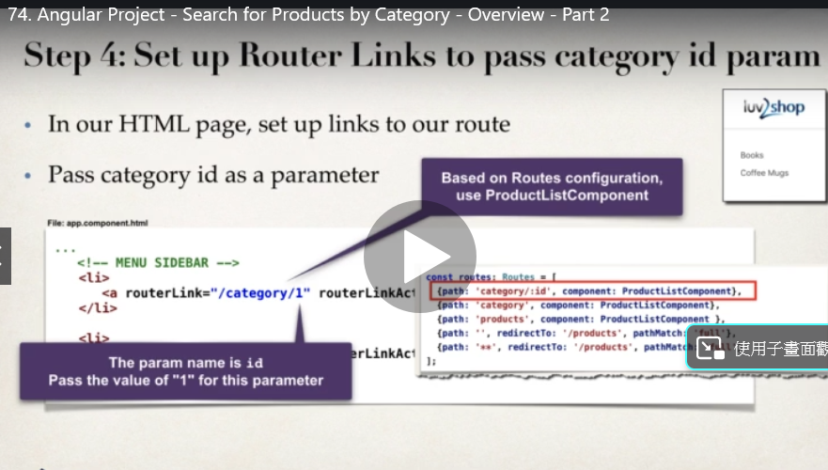

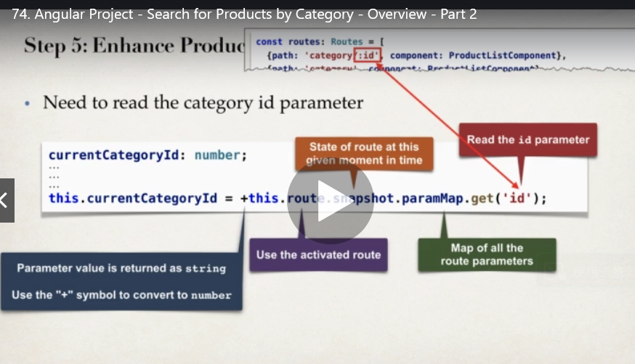

**75 REST**

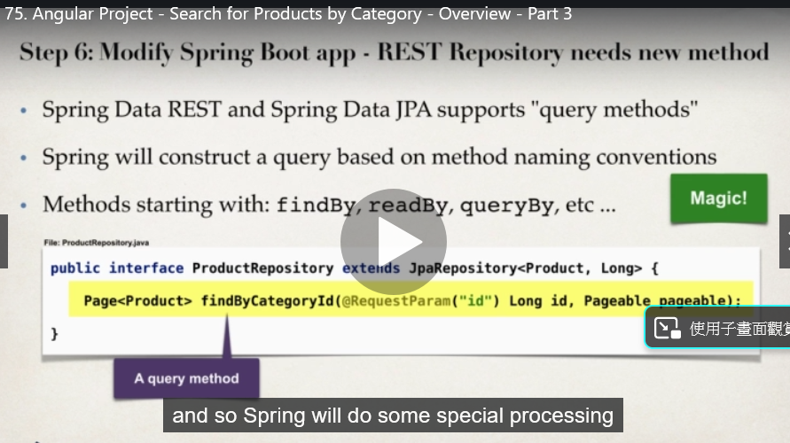

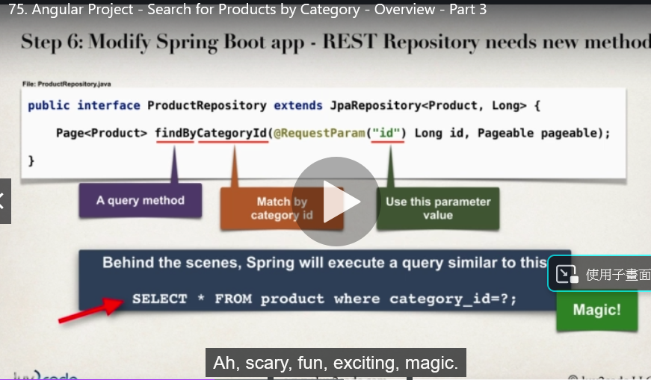

**自己寫query**

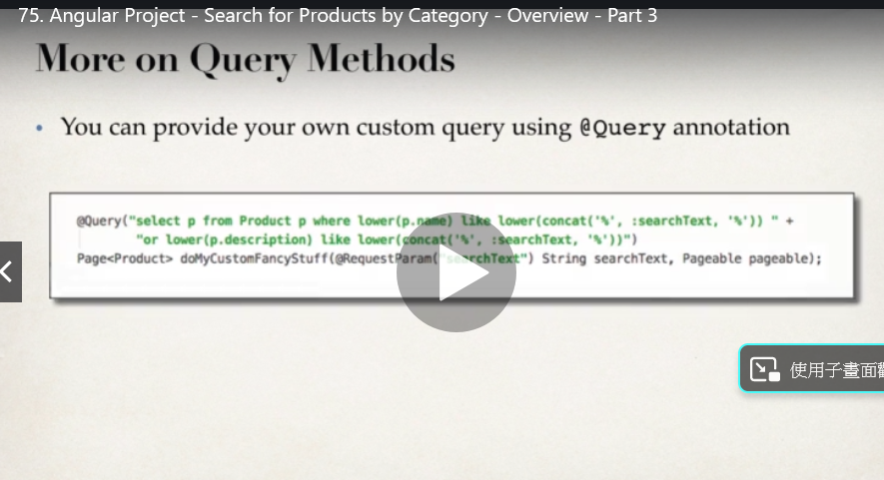

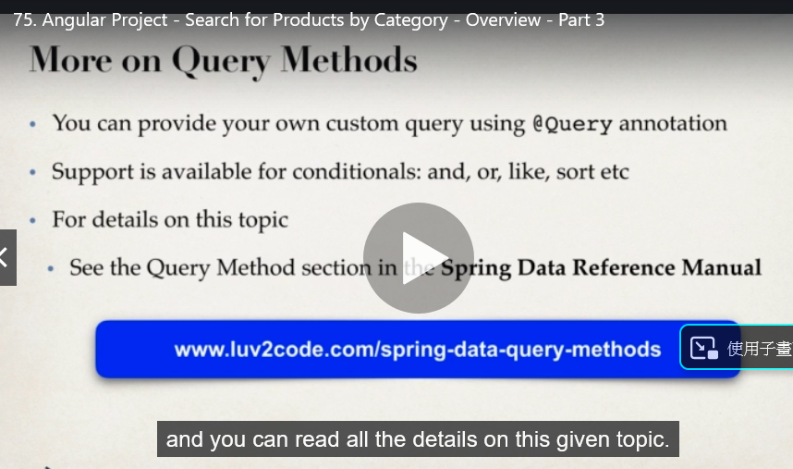

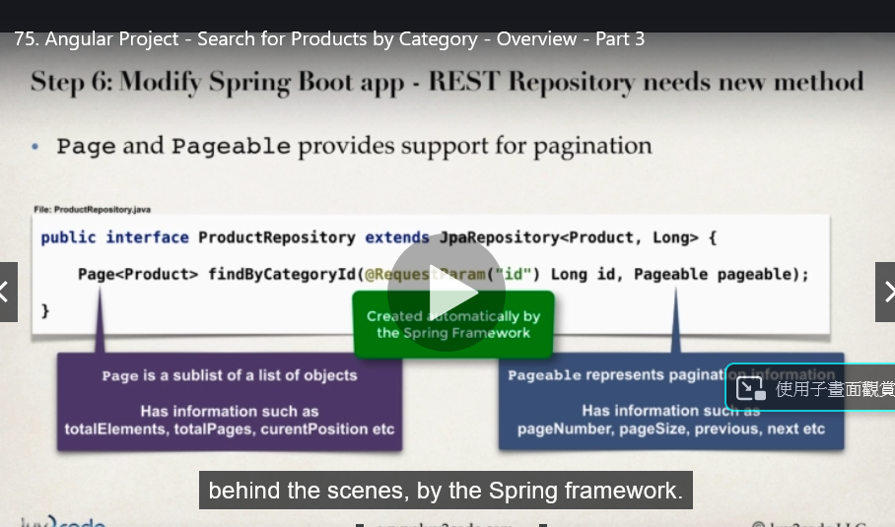

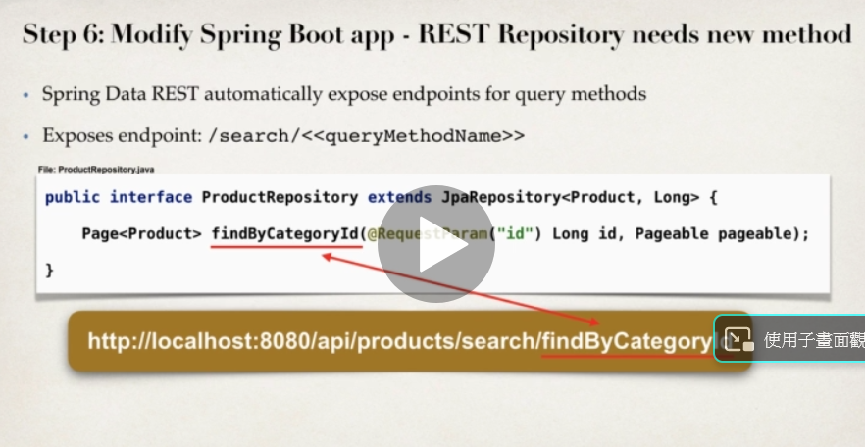**如何傳資料給rest api**

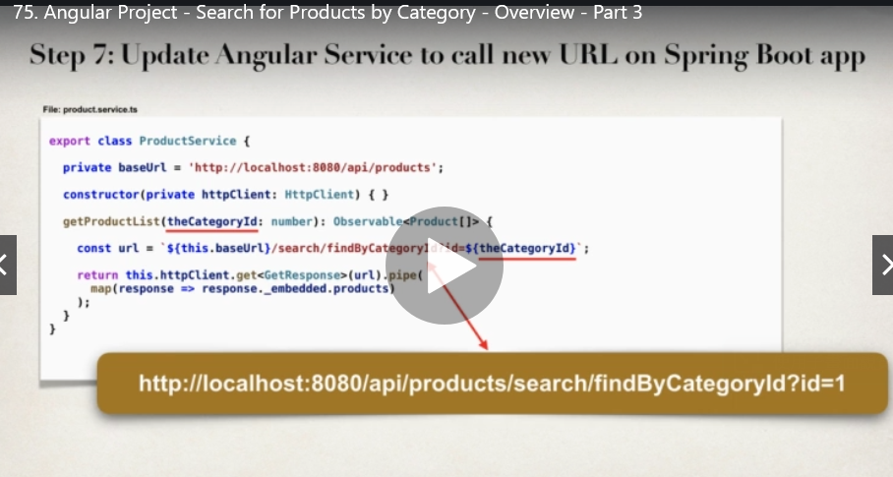

**77 router**

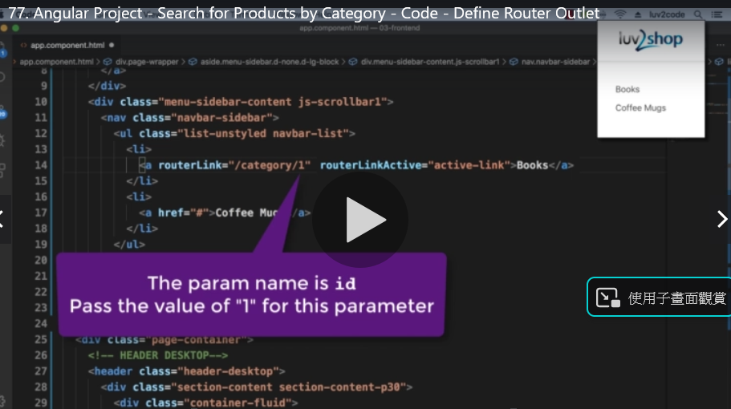

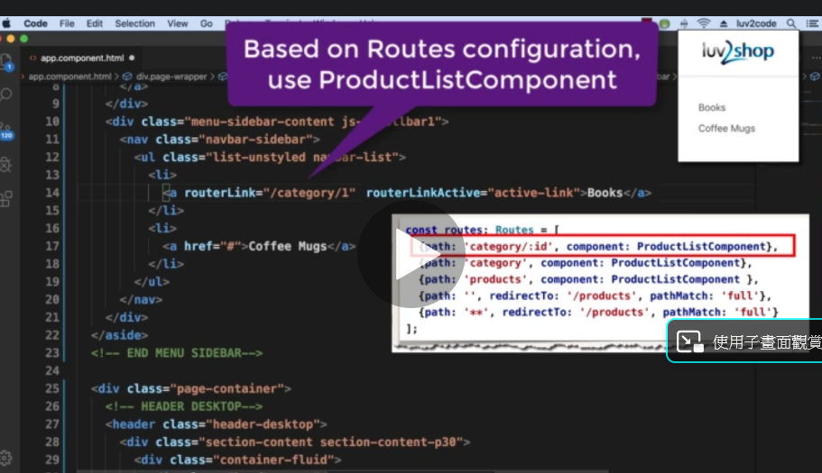

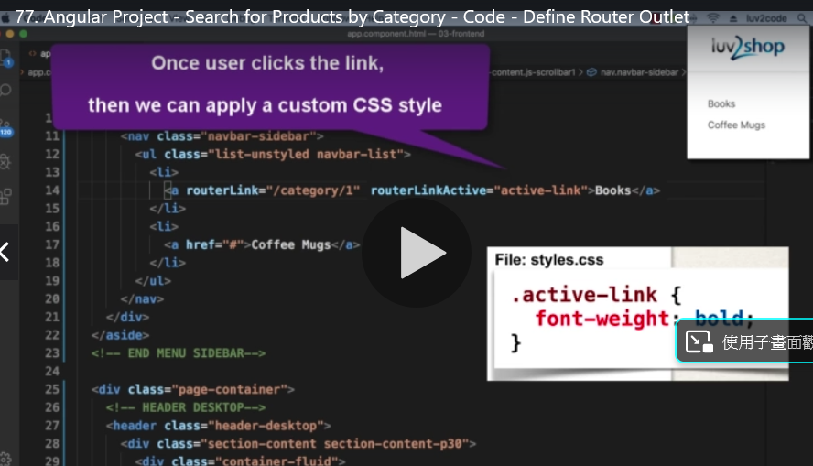

**78**

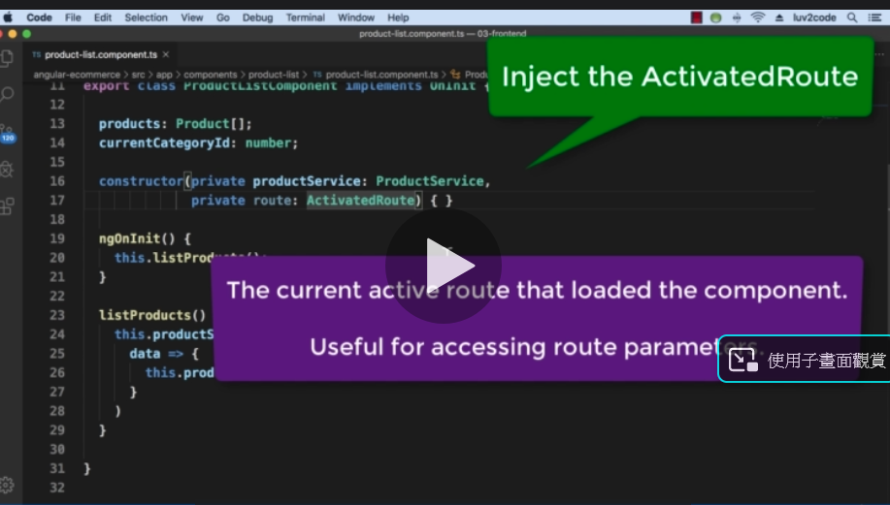

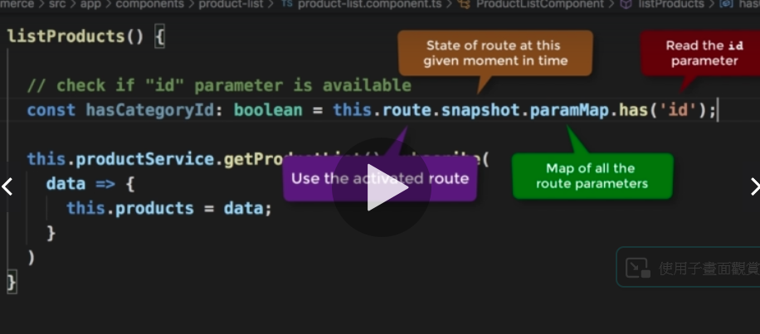

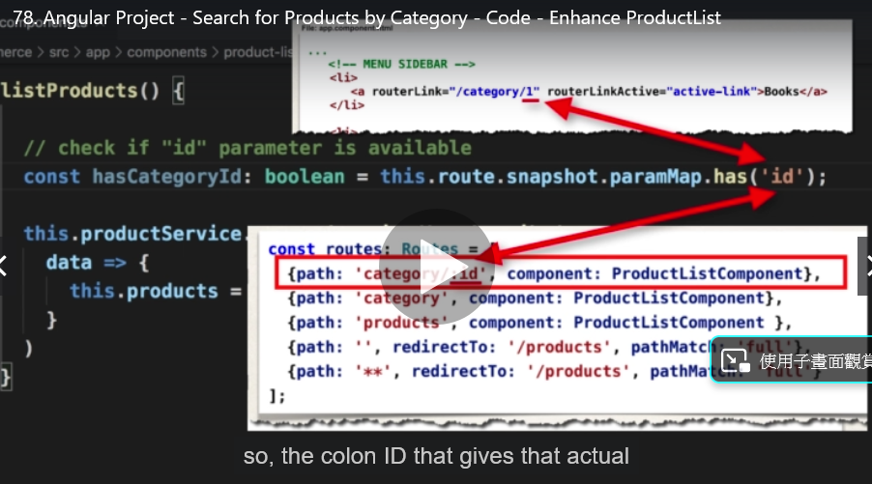

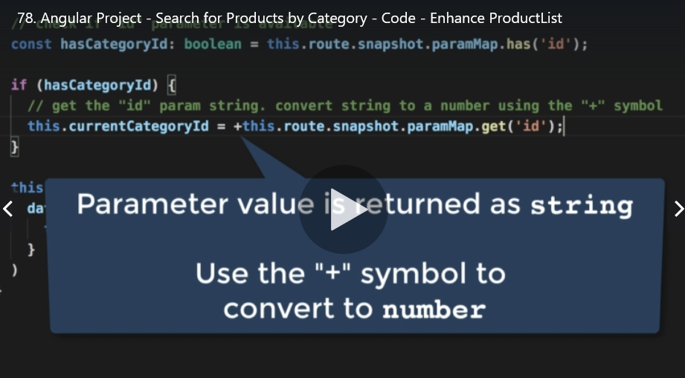

**79 spring 依照方法名稱自動產生query**

**Select * from product where category_id = ?**

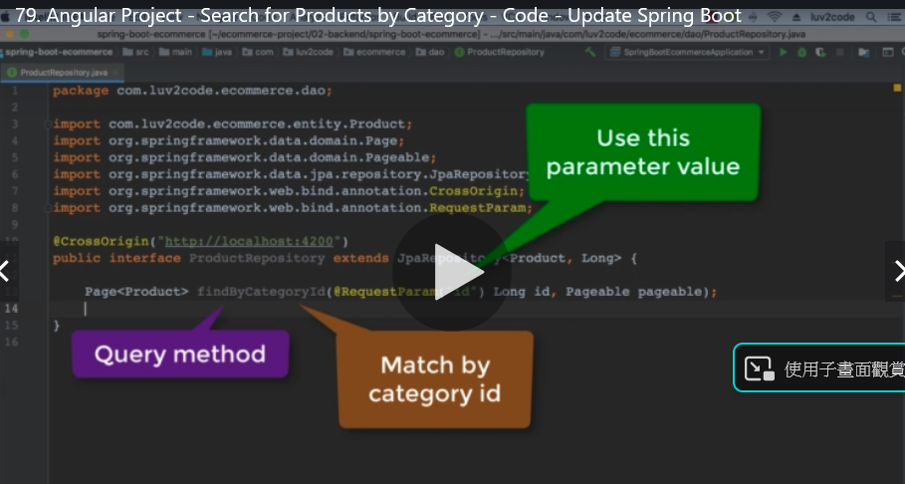

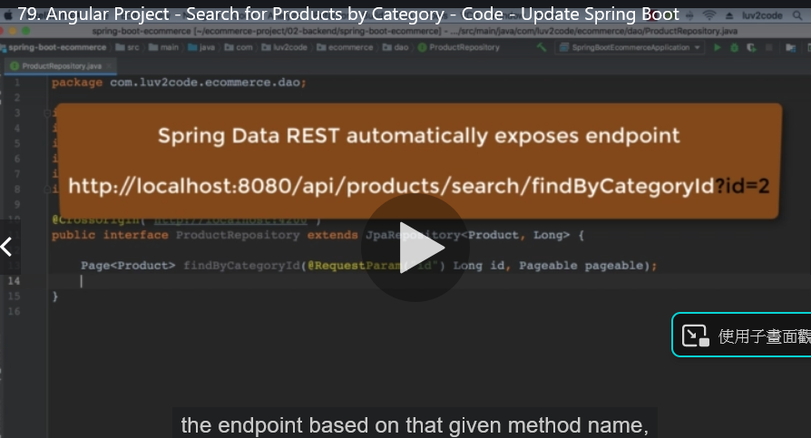

**82 enhance component to read categories from service**

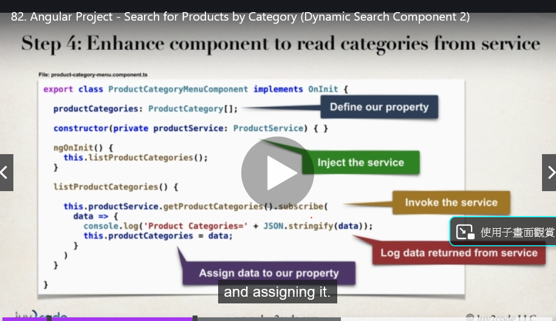

**83 expose id 讓所有的id在json中都顯示出來**

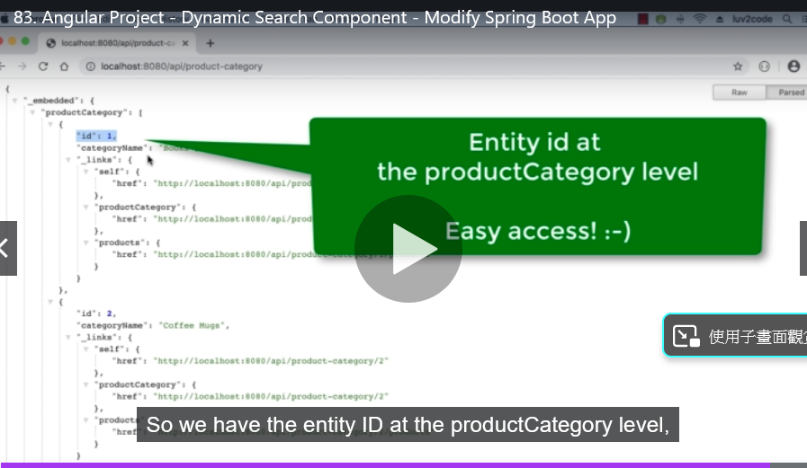

**84 ng generate class common/product-category**

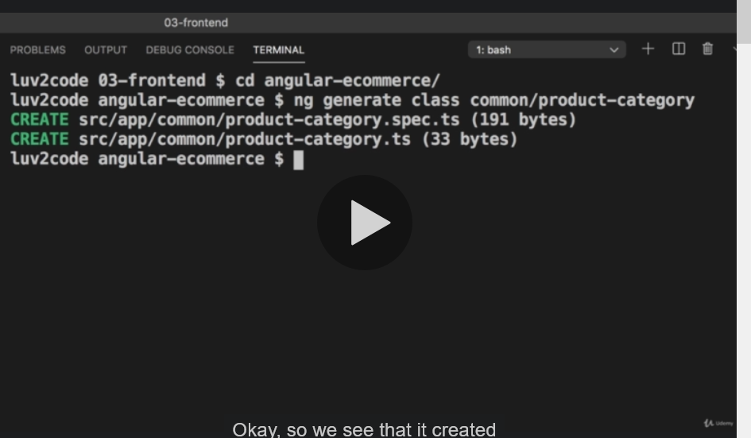

**ng generate component components/product-category-menu**

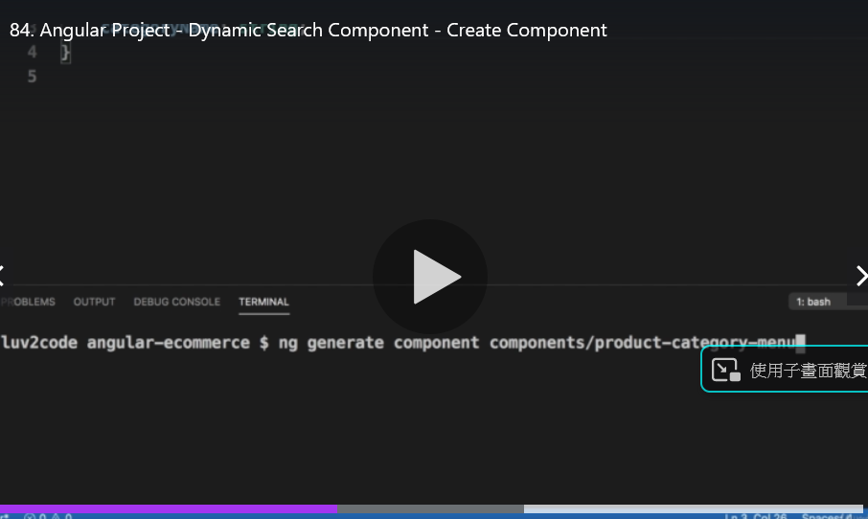

**86**

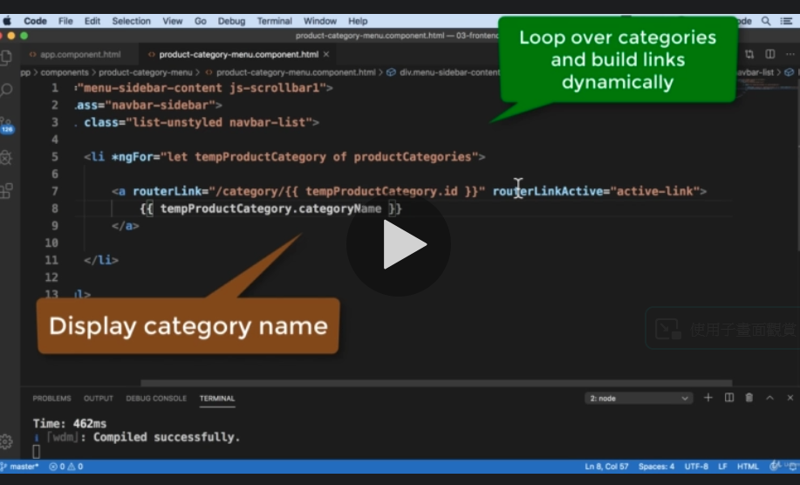

**89關鍵字查詢**

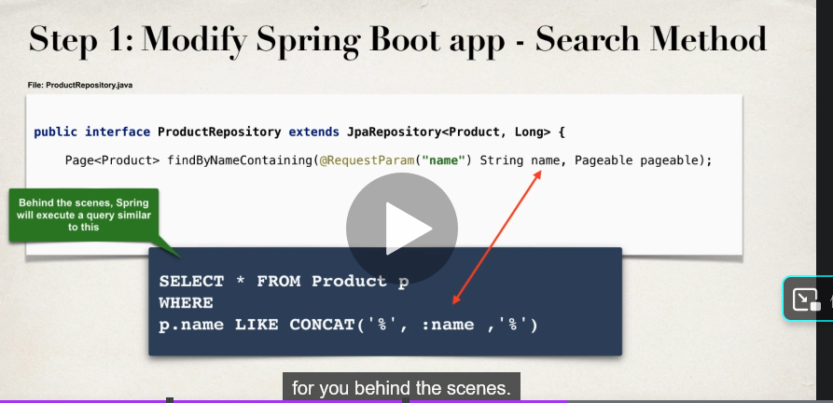

**90 click**

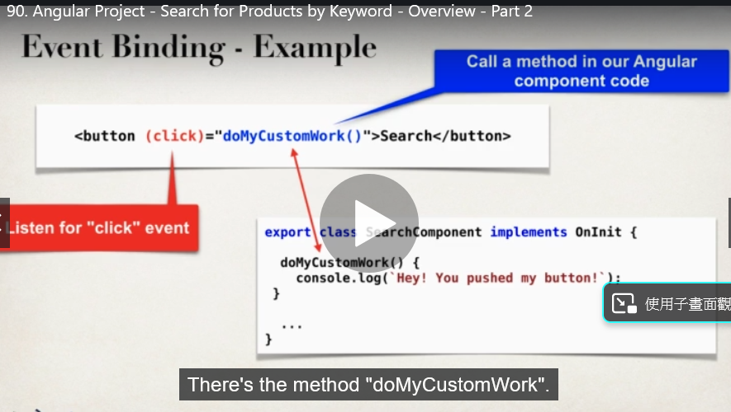

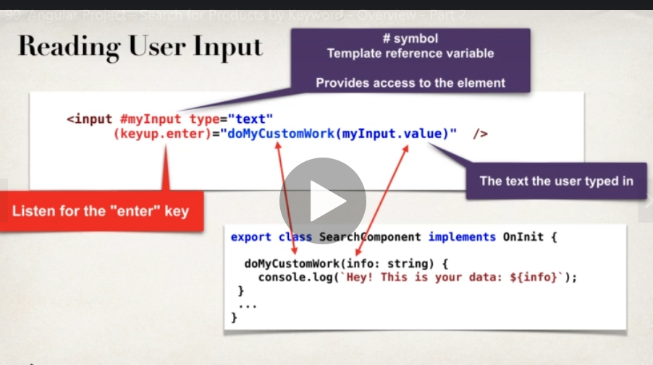

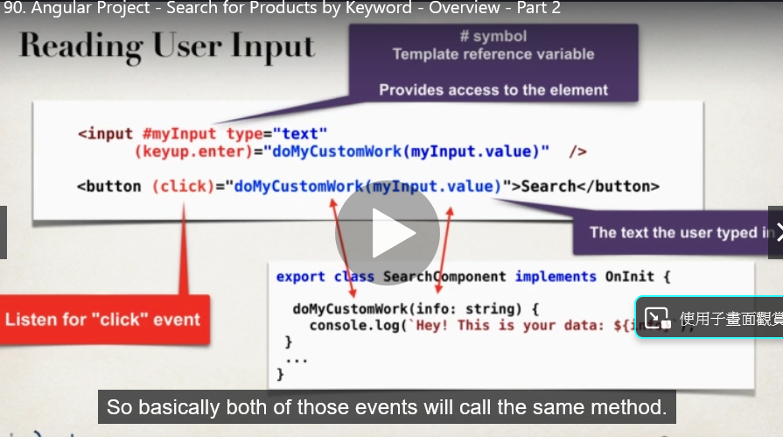

**91**

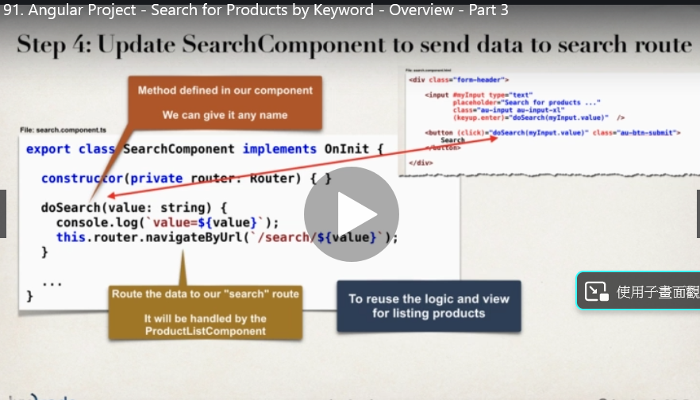

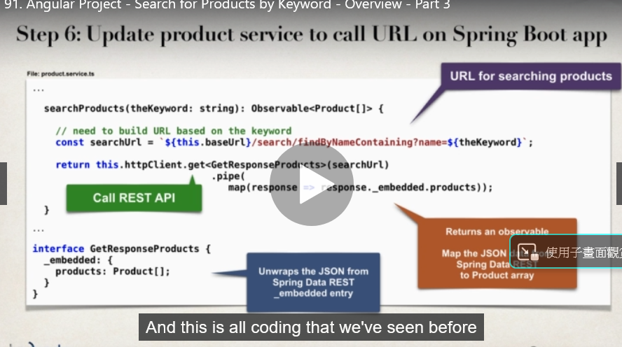

**92 網址 search**

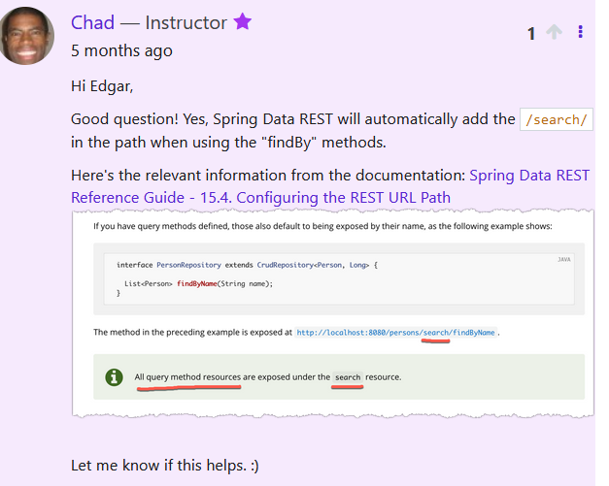

[Spring Data REST Reference Guide - 15.4. Configuring the REST URL Path](https://docs.spring.io/spring-data/rest/docs/current/reference/html/#customizing-sdr.configuring-the-rest-url-path)

94 input search

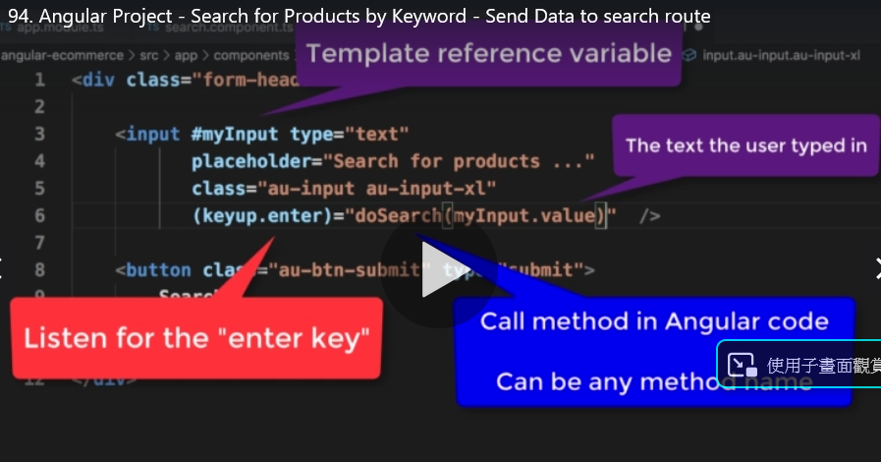

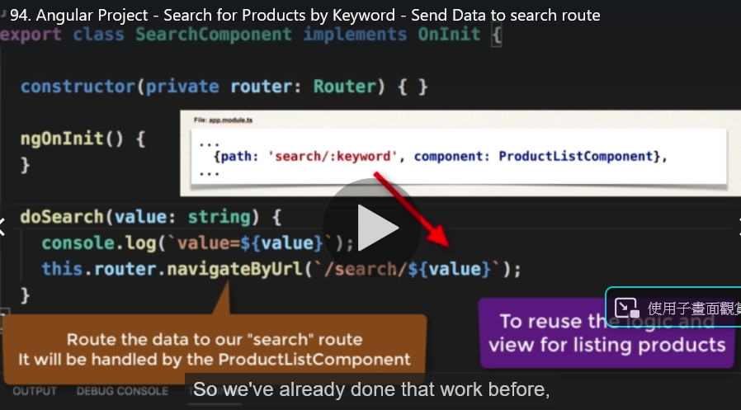

**甚麼事router????**

**97 如果搜尋不到資料的話 role=”alert”**

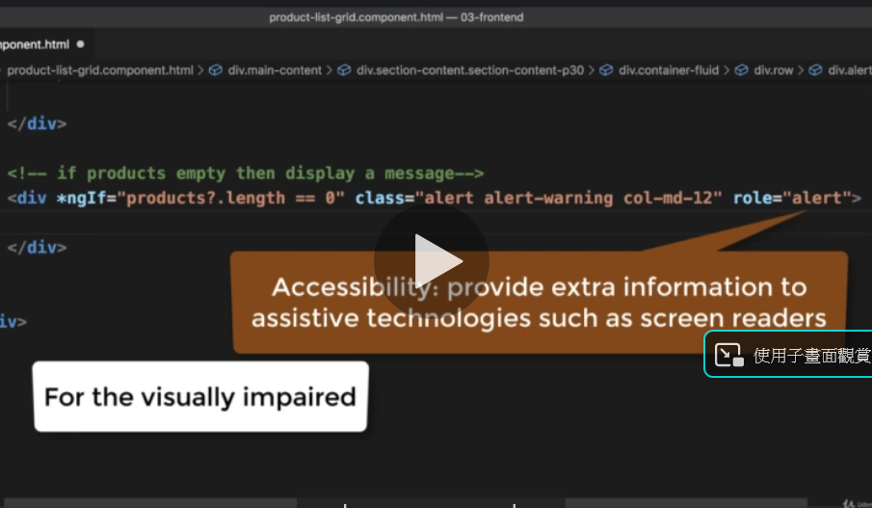

**www.luv2code.com/angular-safe-navigation-operation**

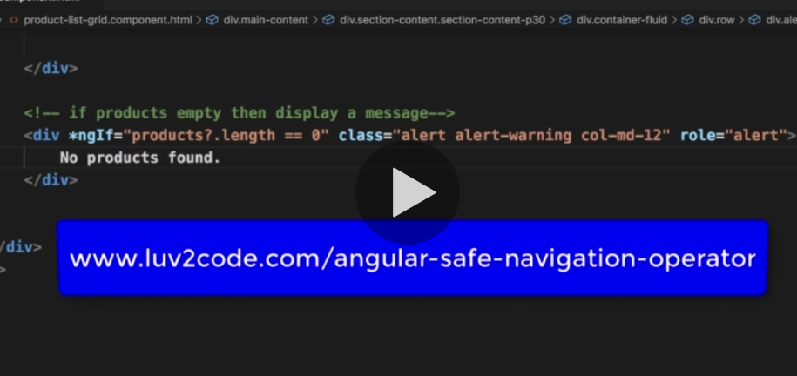

**99 spring data rest api no additional coding/config required**

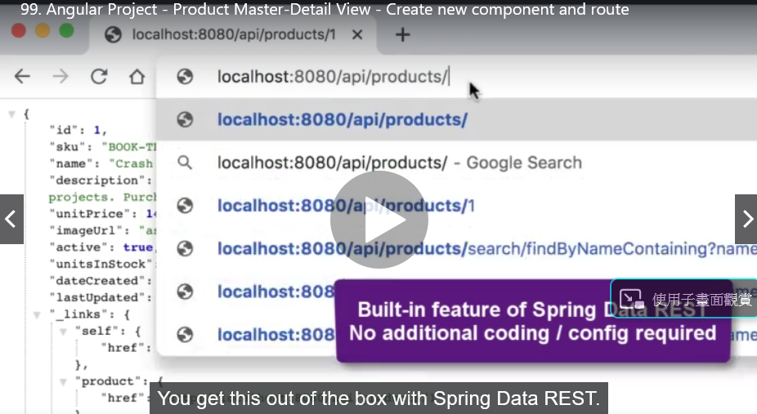

**105 conponent中 並沒有id這個property 但卻可以使用?? Why?**

**他叫我安裝Angular Language Service**

**104**

ERROR TypeError: ctx.product is undefined

    ProductDetailsComponent_Template product-details.component.html:4

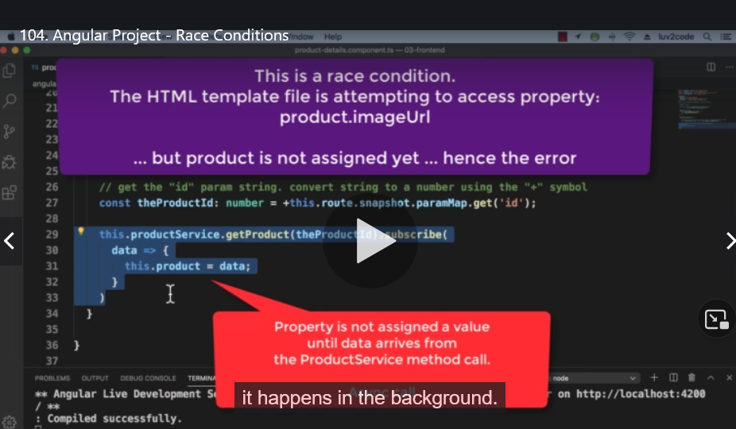

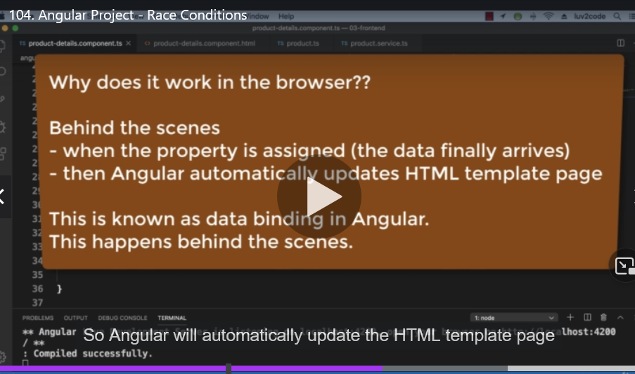

**106 page pagination**

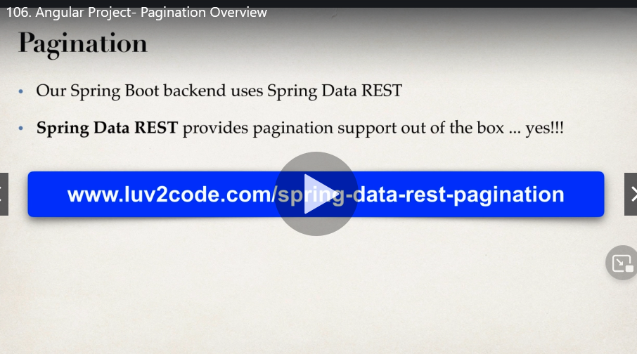

**預設是20個 elements**

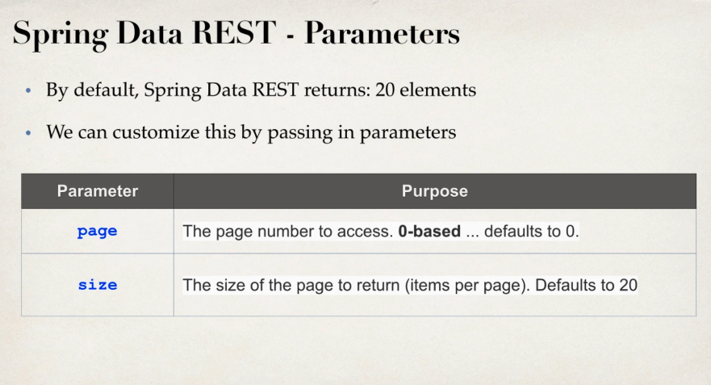

**Spring data rest response meta data**

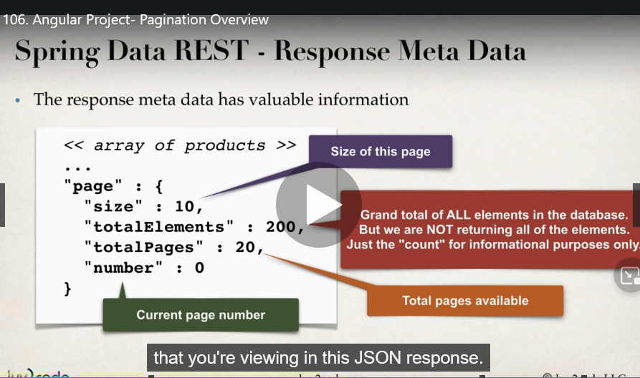

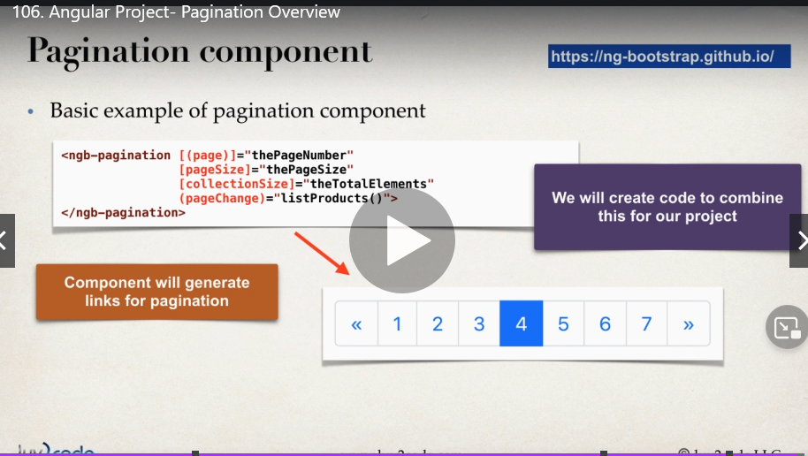

**107 install ng-bootstrap**

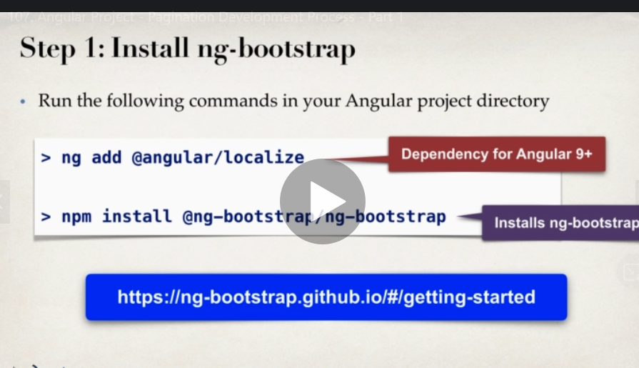

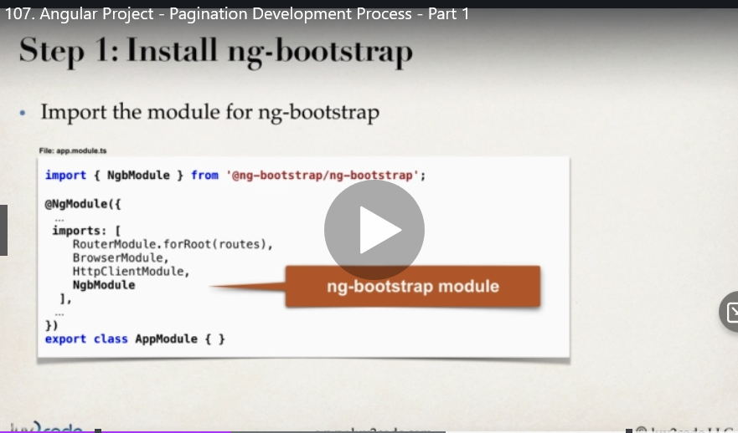

**109**

[**http://localhost:8080/api/products?page=0&size=10**](http://localhost:8080/api/products?page=0&size=10)

**這個pagination是spring data rest api 提供的**

**ng add @angular/localize**

**npm install @ng-bootstrap/ng-bootstrap**

**110**

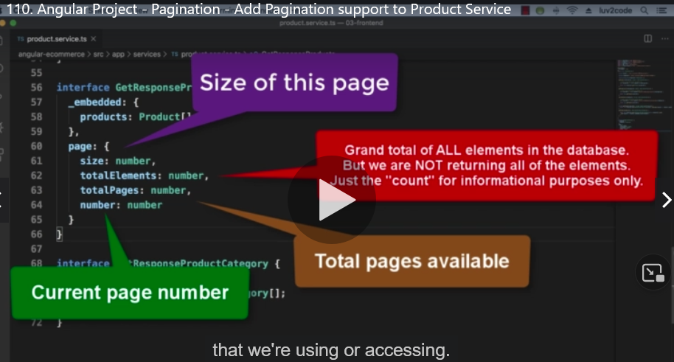

**111**

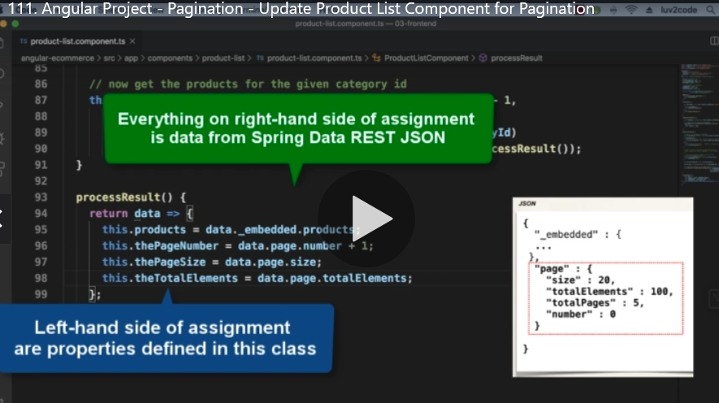

**112**

**Pagination**

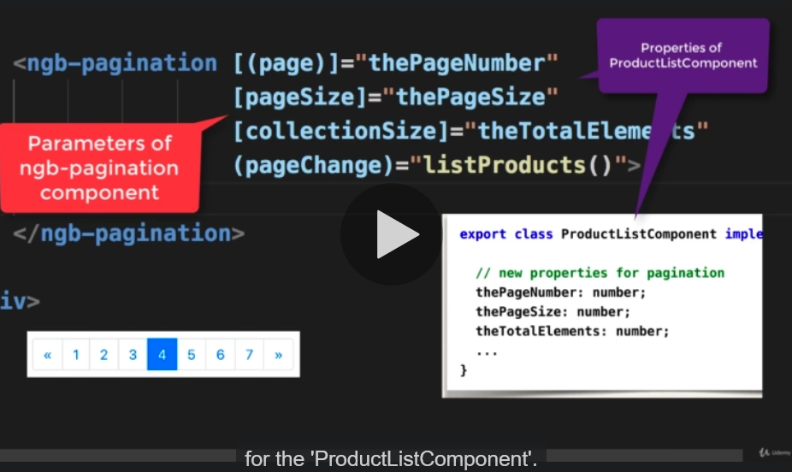

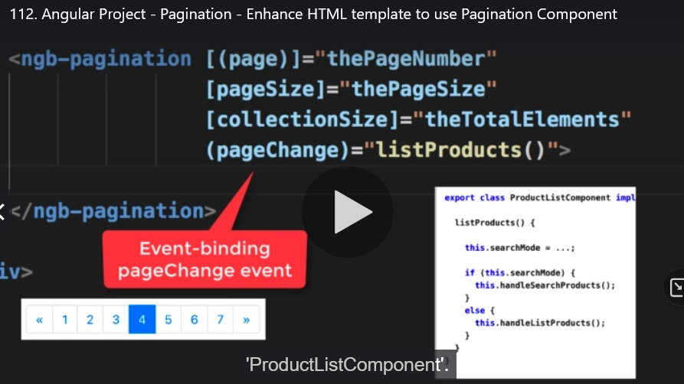

**115 下拉式選單**

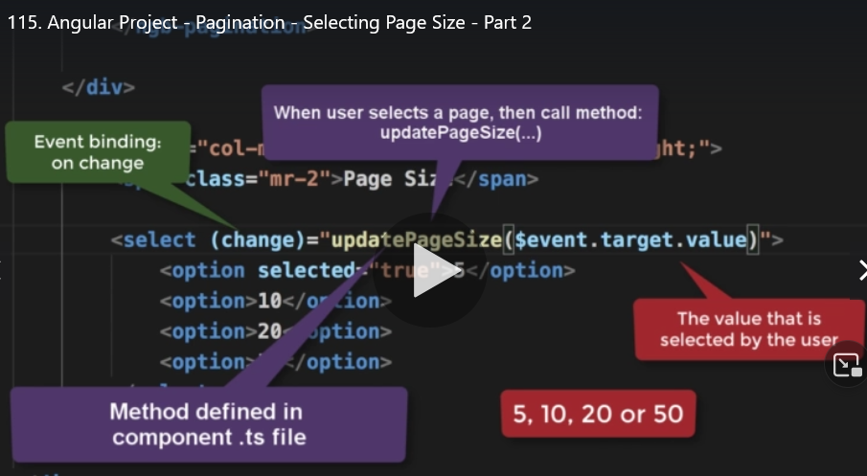

116最大分頁數

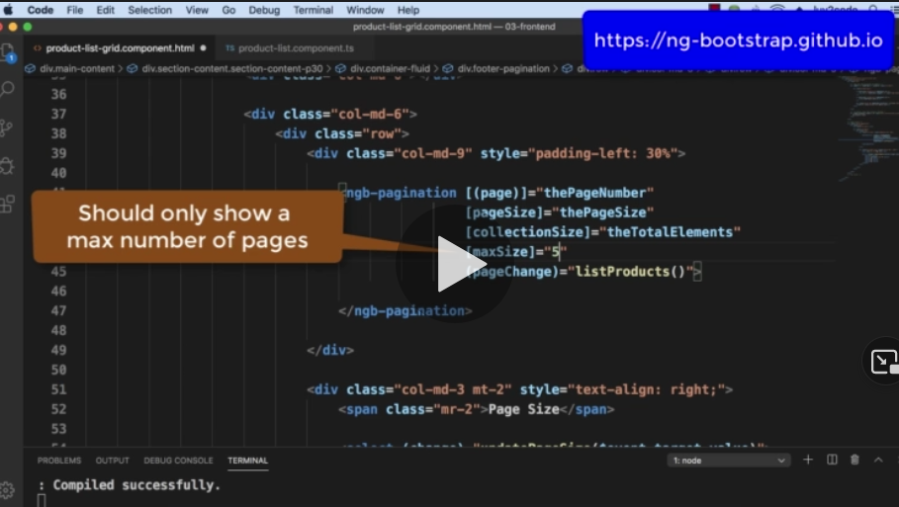

**123 cart**

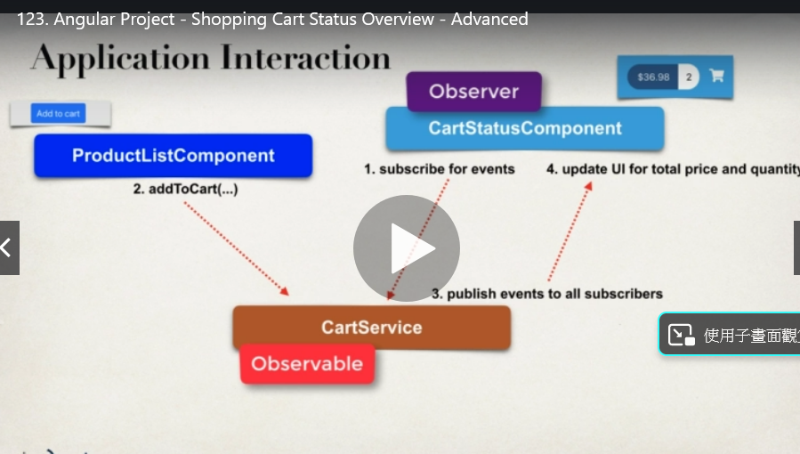

**131 find**

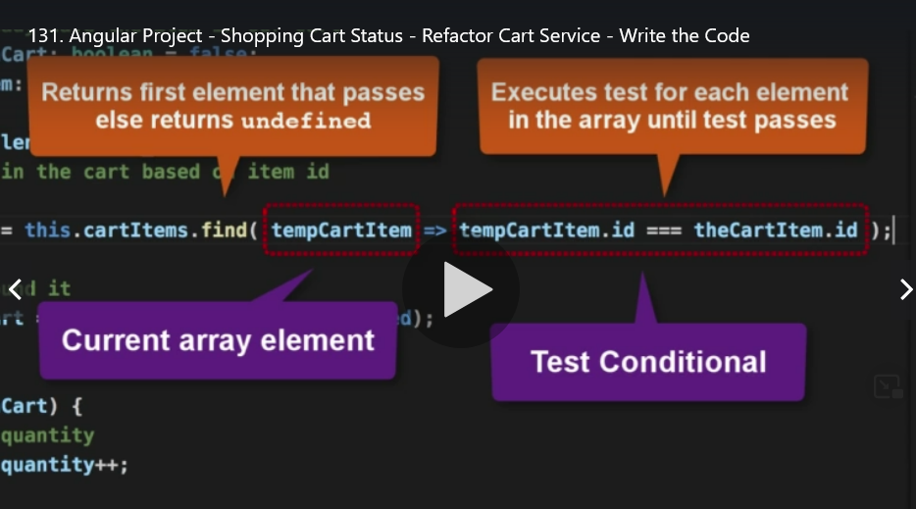

**148 form group**

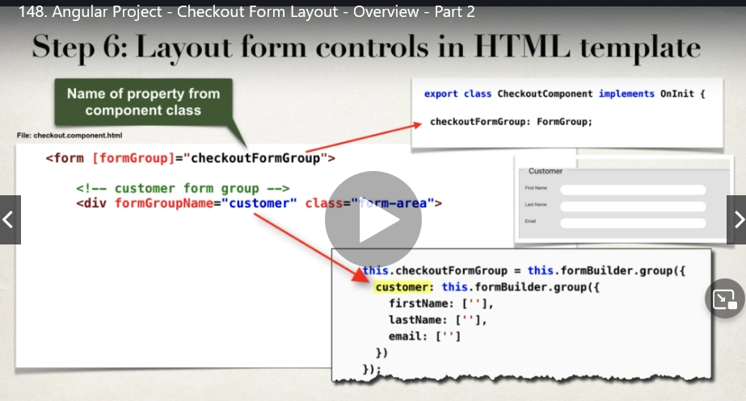

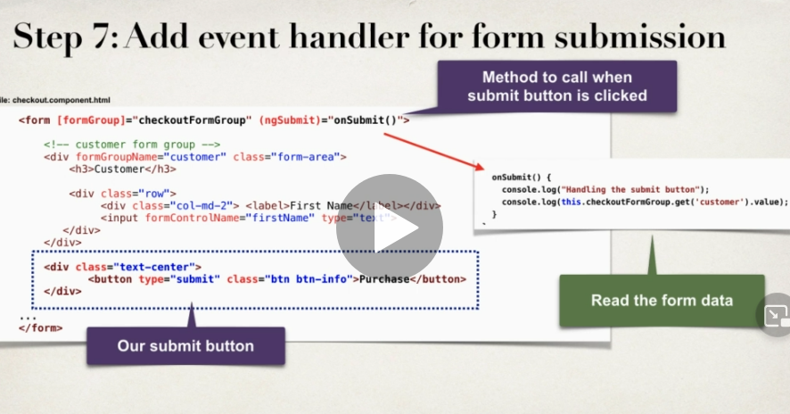

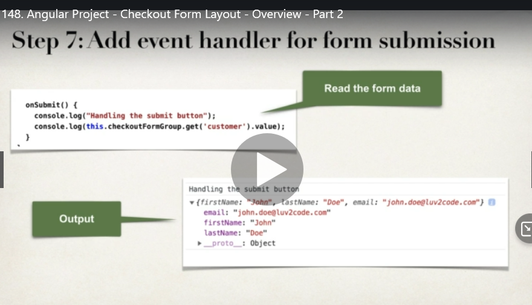

**151 formGroup**

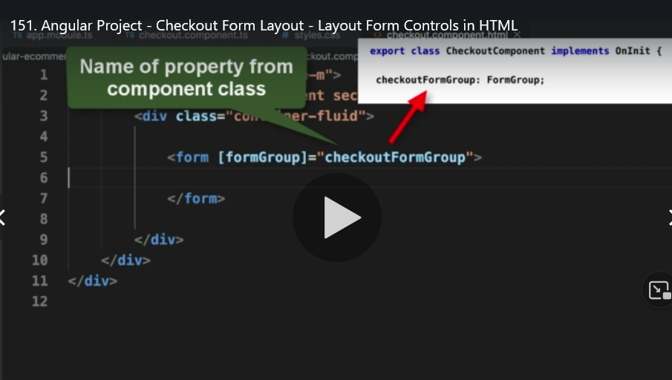

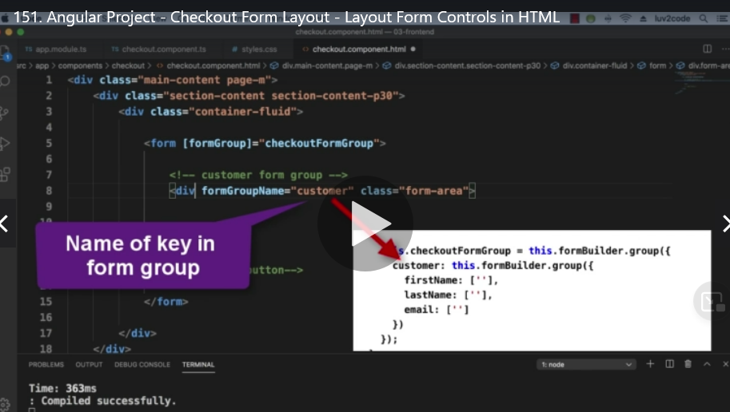

**formControl**

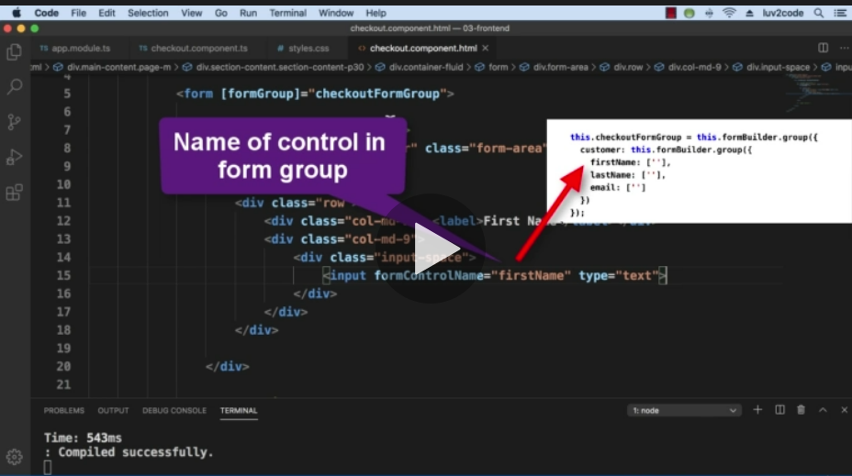

**157 observable of rxjs**

**Observable會回傳一個observable 物件**

**而我們要回傳的時候 在前面加上of並把要回傳的物件()起來 ex : of(data)這樣就會把這個回船務物件包起來當作是一個observable的物件**

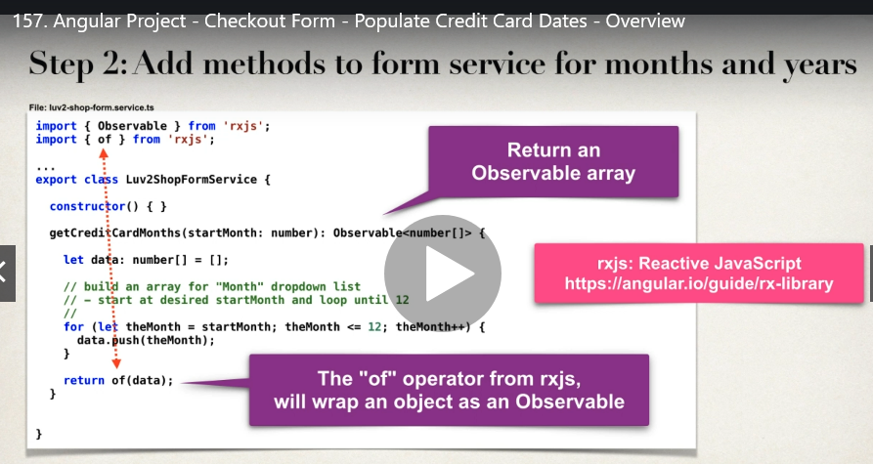

**動態產生 前後十年月**

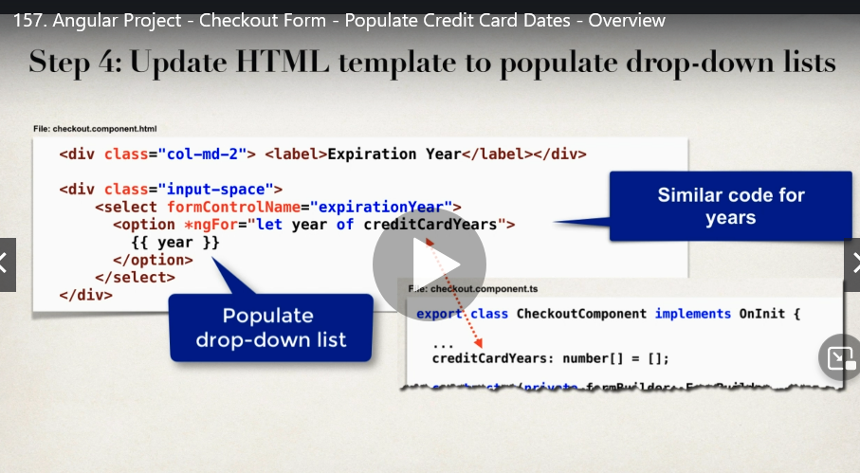

**158 of**

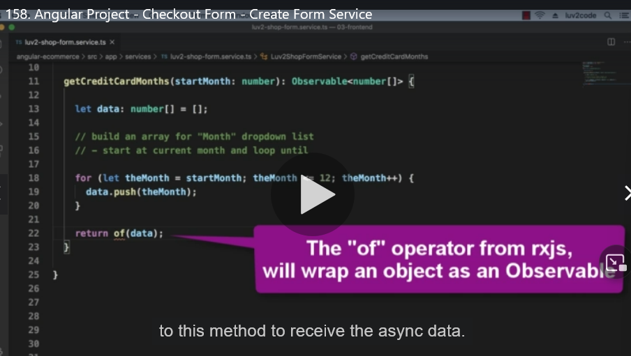

**163 manytoone oneto many**

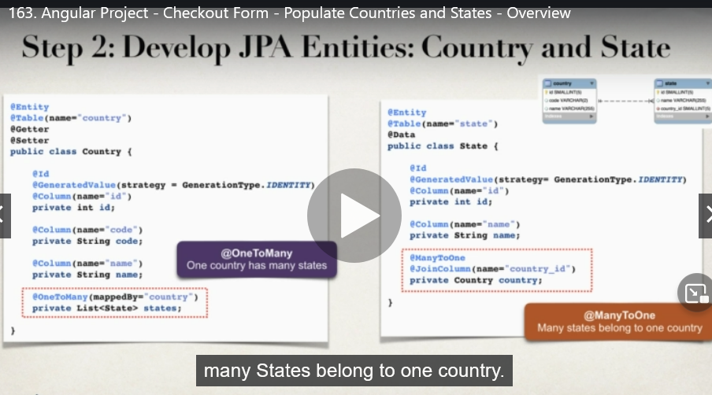

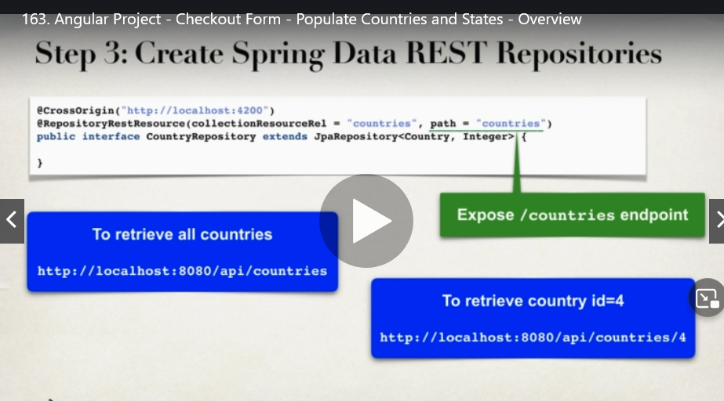

**166 建立 restful api**

**JsonIgnore**

1. **建立database**
2. **建立entity 設定關聯**
3. **建立dao(interface extends JpaRepository<the entity型別, PK型別>**
4. **依照 spring data的規則新增方法**

**Ex:** List<State> findByCountryCode(@Param("code") String code);

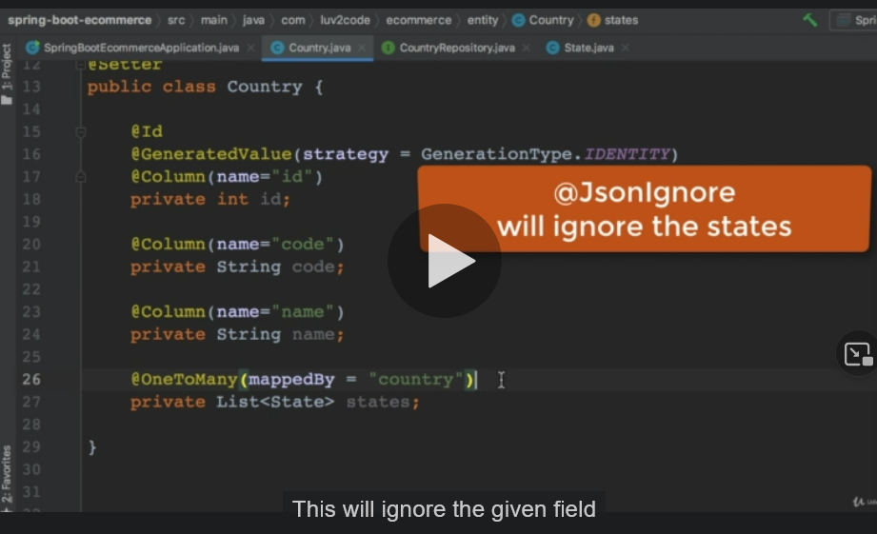

**167 spring data jpa**

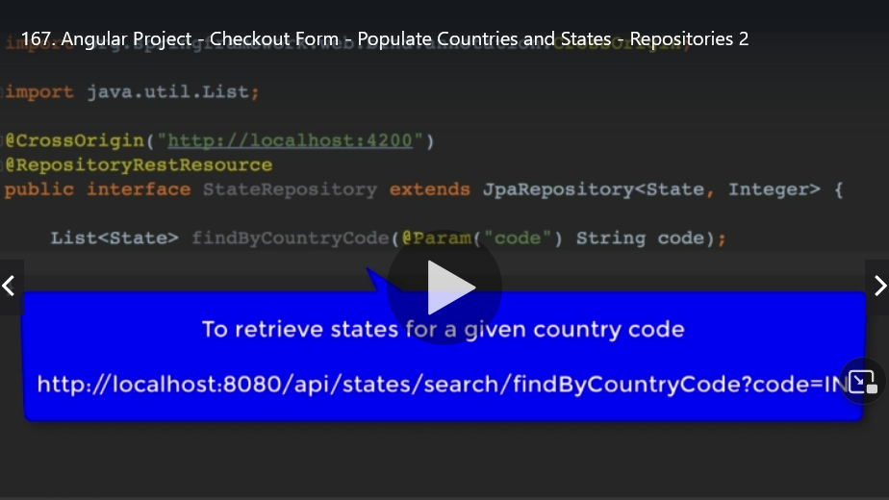

**171 _embedded**

**Unwraps the JSON form Spring Data REST _embedded entry**

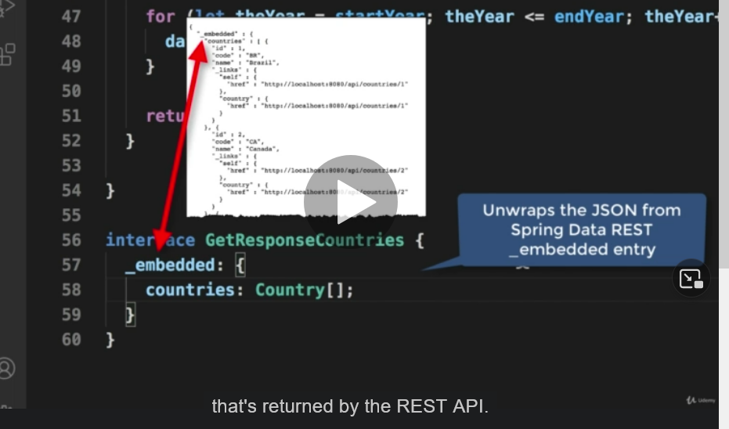

**172 ngFor ngValue**

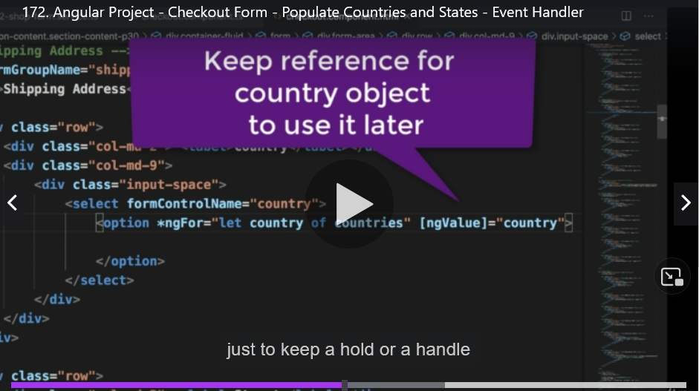

**地20節有 從 database 經過後端 一直到把資料顯示在前端上的所有經過**

**177 angulaar validation**

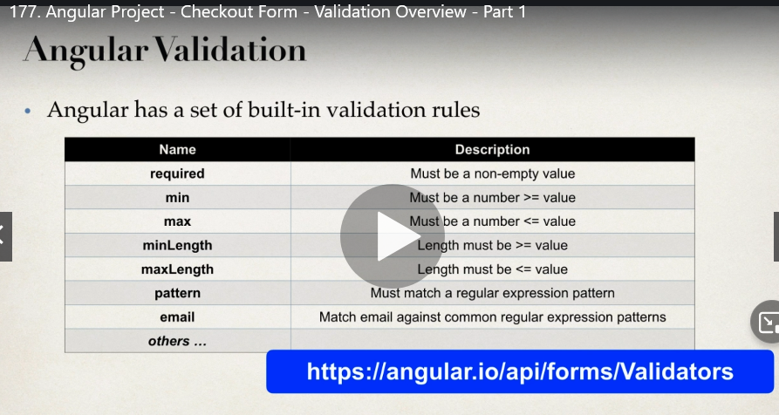

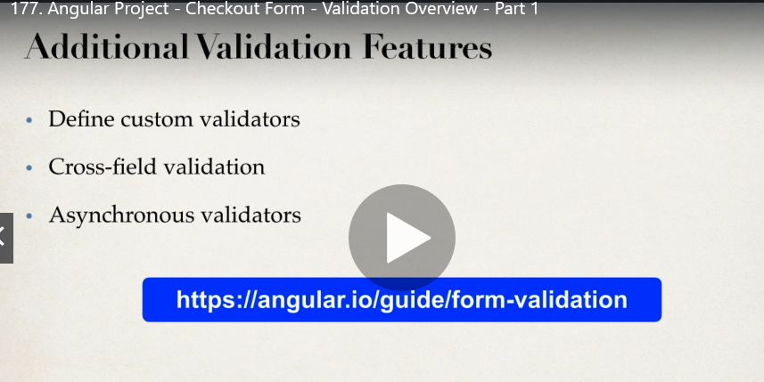

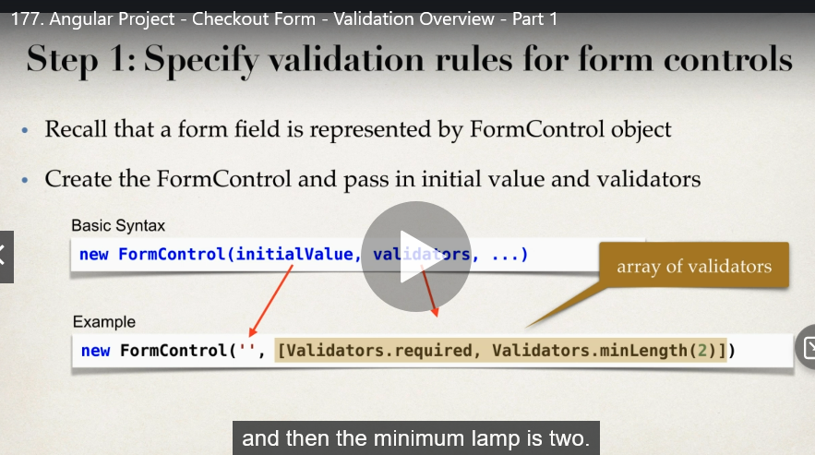

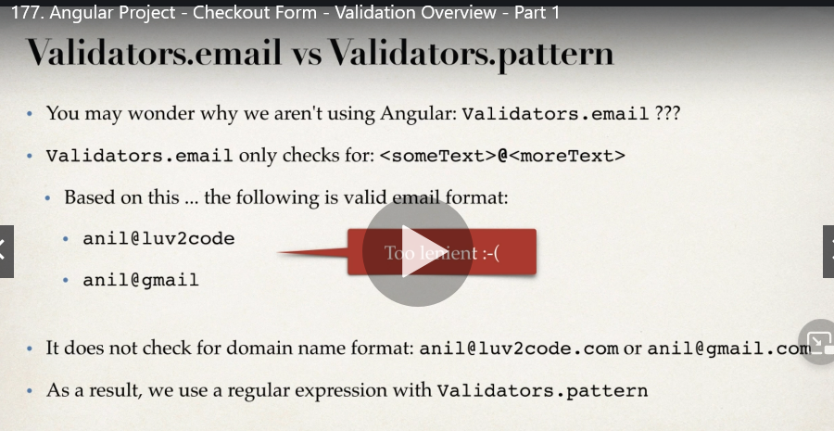

**178 validation**

Dirty

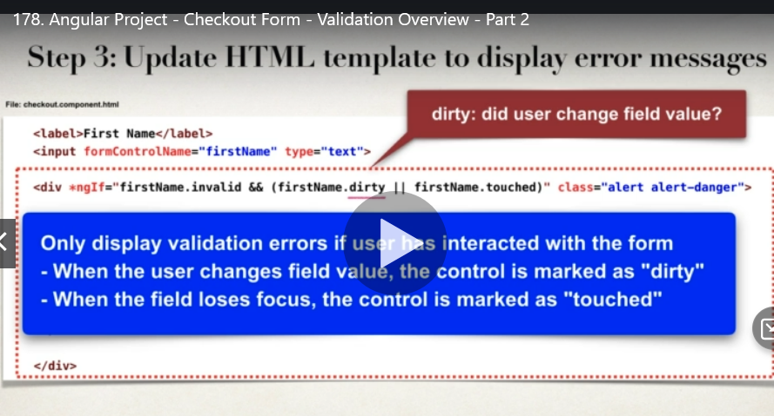

**Touch**

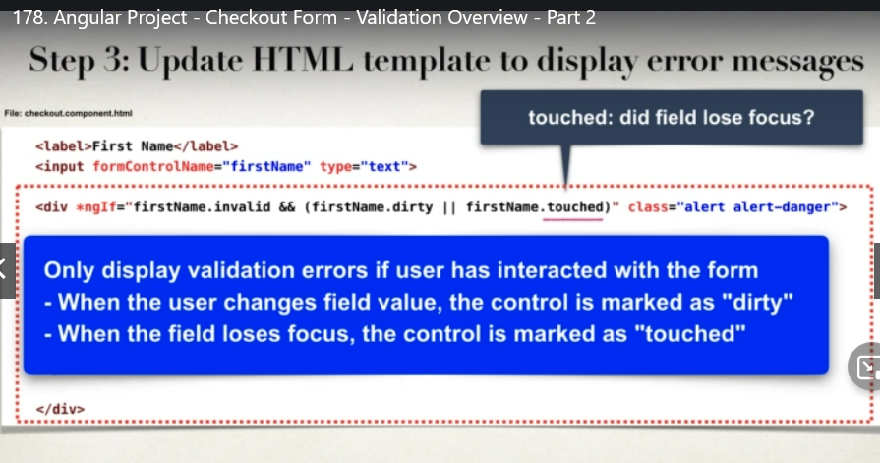

**Errors**

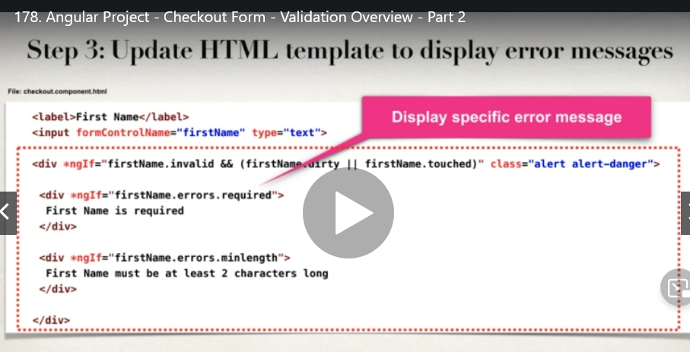

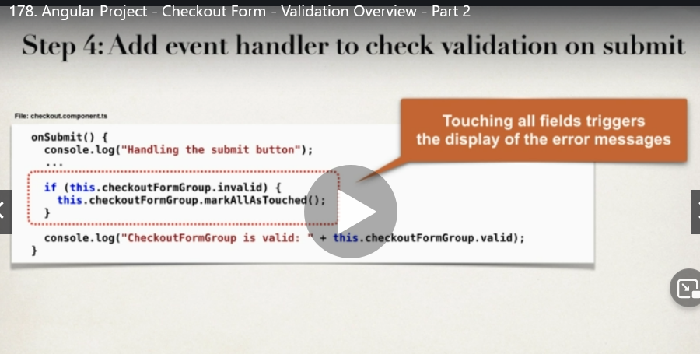

**179正則表示式**

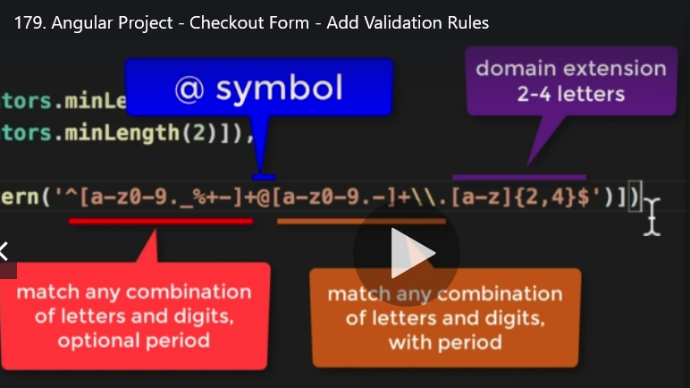

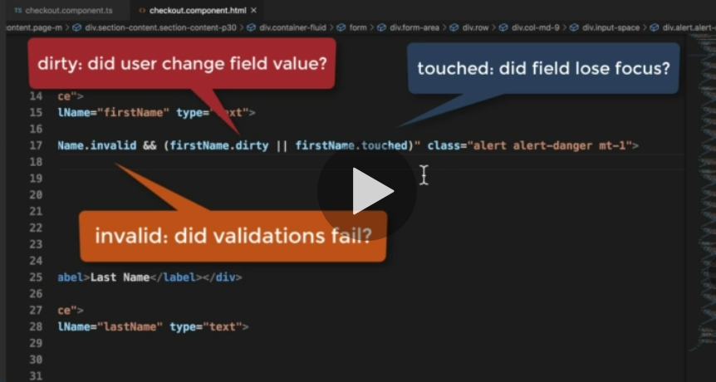

**181 invalidation**

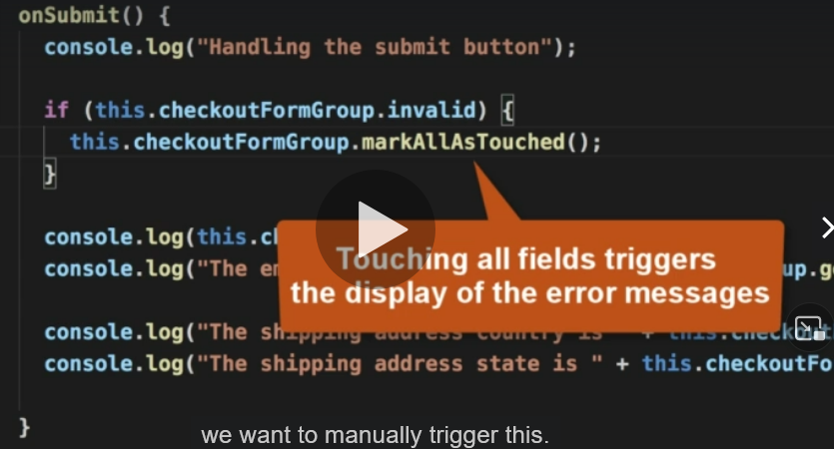

**182 trim**

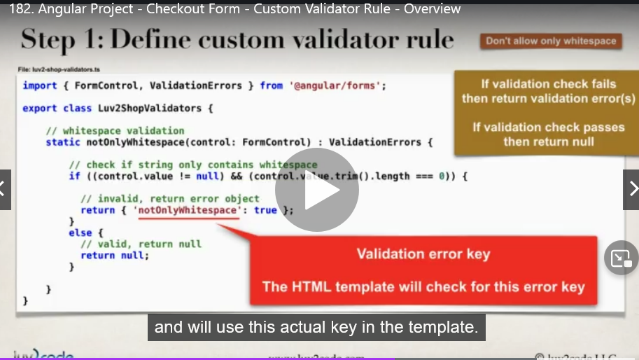

**183 validators new class**

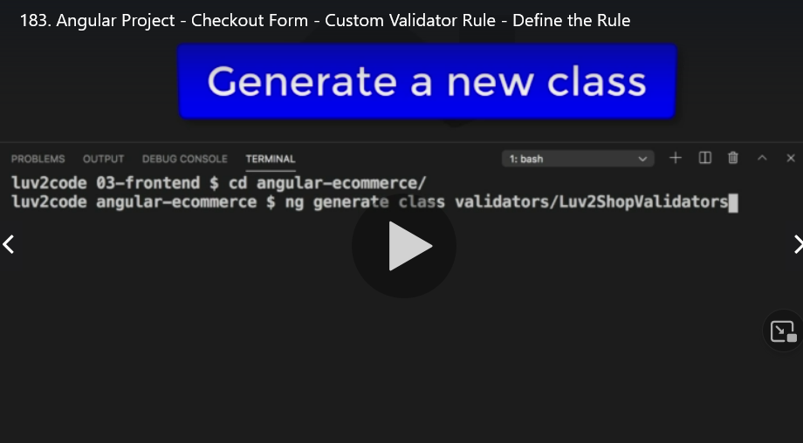

**Error key**

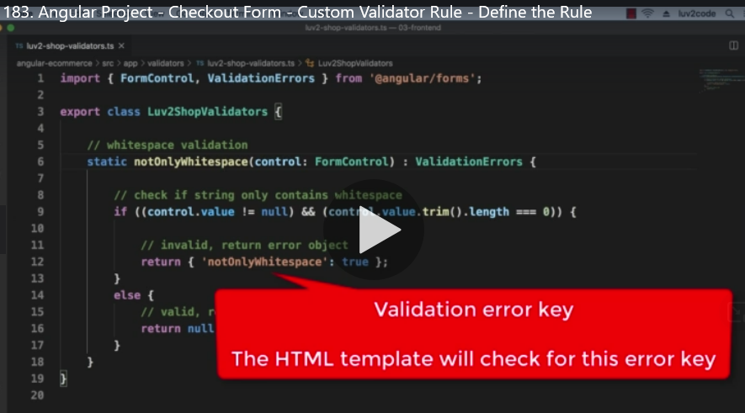

**184 validation error key**

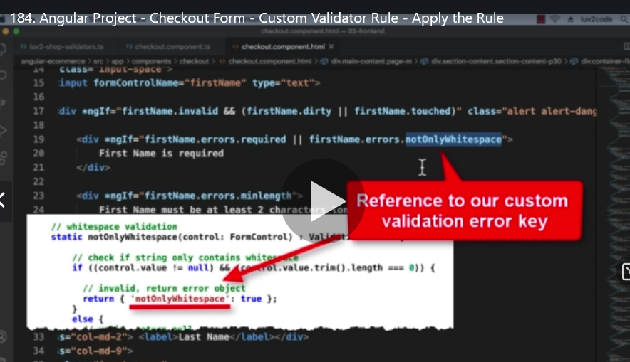

**194 Replysubject**

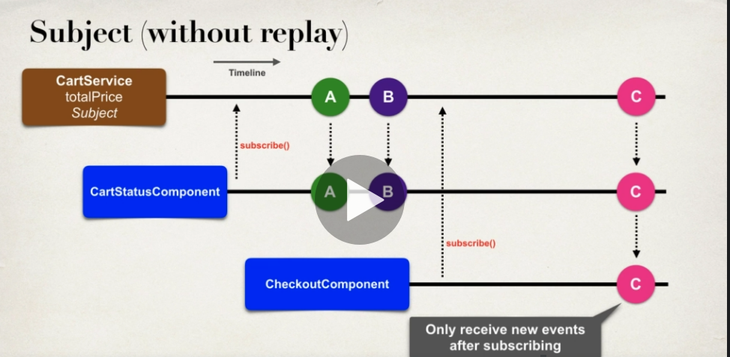

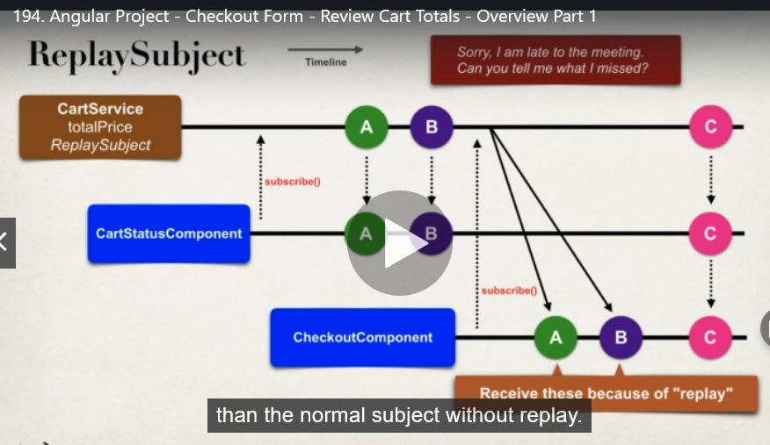

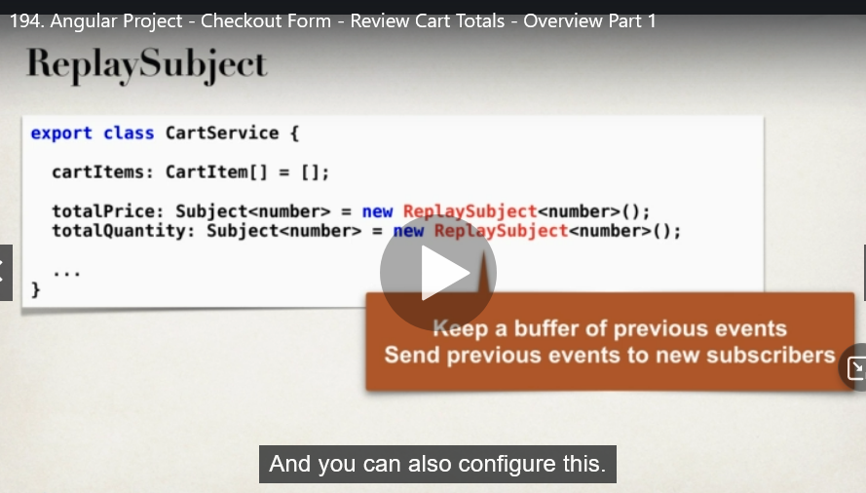

**195 behaviorSubject 取得最後最新的資料**

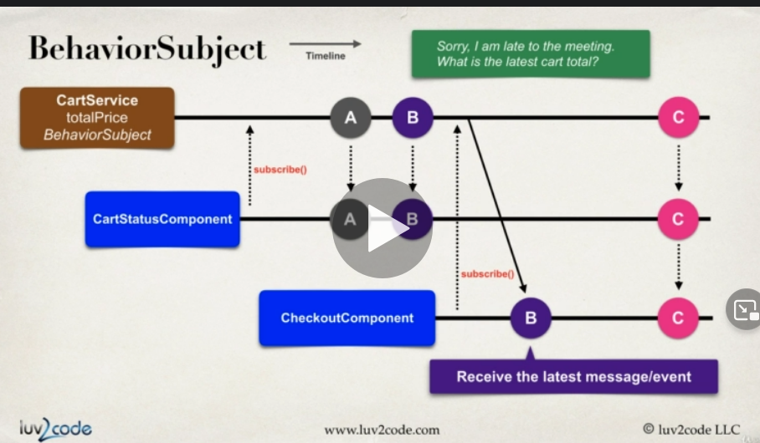

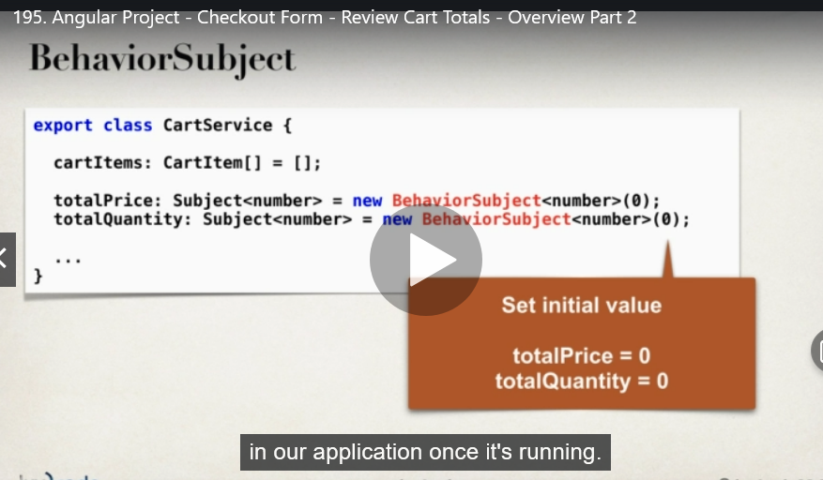

**Subject**

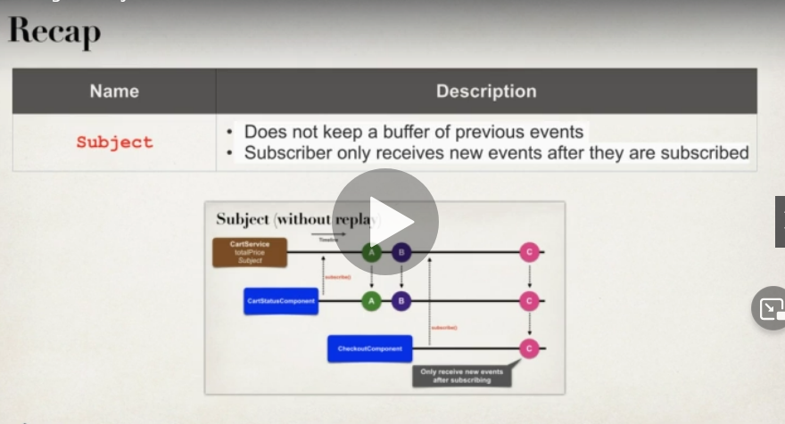

**replySubject**

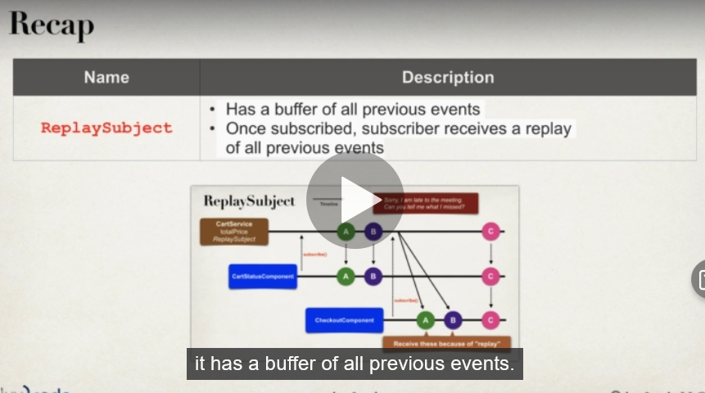

**Bejaviorsubject**

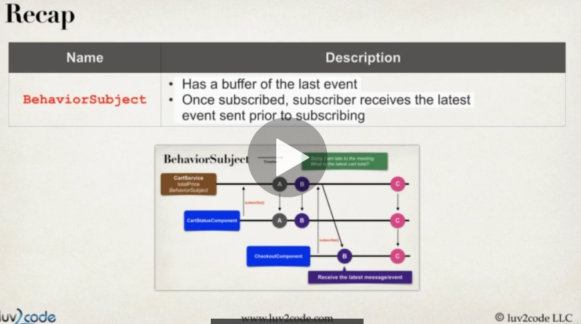

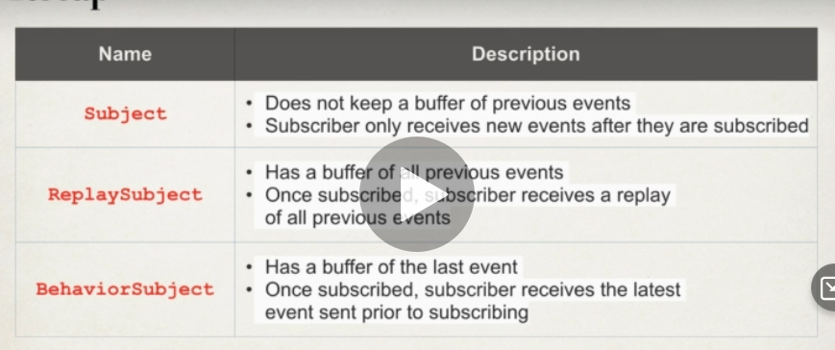

**199**

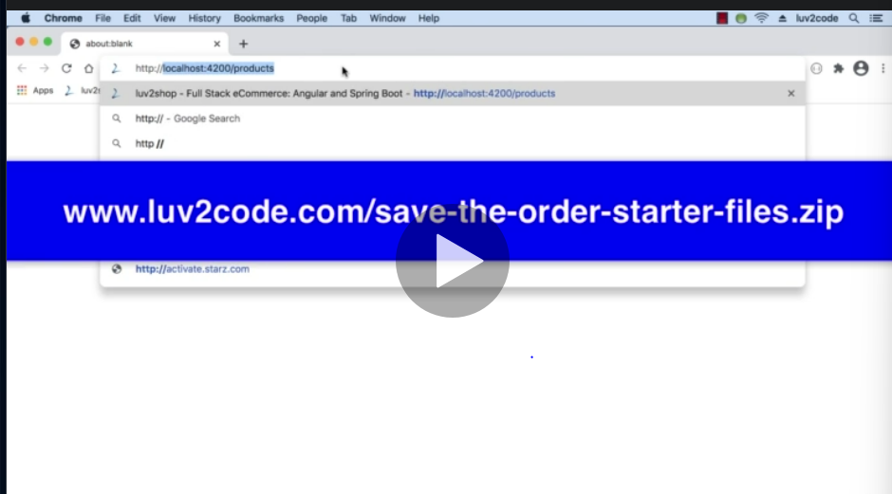

**202 TABLE間的關係**

**203 @primaryKeyJoinColumn**

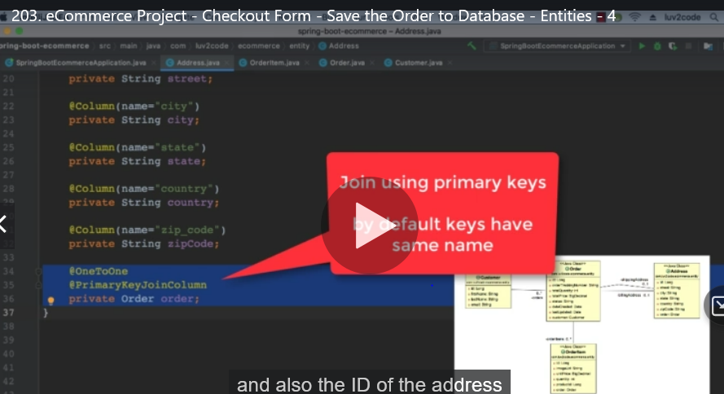

**206 uuid**

